MoonLITE Science Requirements

Prepared by:

Ian Crawford – Birkbeck College London
Alan Smith – University College London

Contents

1. Scope 3
2. Introduction 3
2.1 The Moon 3
2.2 Mission Concept 4
2.3 Penetrators 4
2.4 Current and Future Space Missions 4
3. Science Requirements 4
3.1 Themes 4
3.2 Lunar seismology 5
3.3 Lunar heat-flow 7
3.4 In situ geochemistry 8
3.5 Polar volatiles 8
4. Lunar Exploration Requirements 9
5. Requirements Summary 9
6. References 10

Scope
This document describes the MoonLITE Science Requirements. In fact the configuration of MoonLITE must address three sets of requirements, vis:

- Science Requirements
- Lunar Exploration Requirements
- Strategic Requirements

Included in this document under Science Requirements are also the requirements associated with the preparation for downstream lunar exploration including manned exploration.

Strategic Requirements are beyond the scope of this document and are given in ‘MoonLITE Strategic Requirements’.

Introduction

The Moon
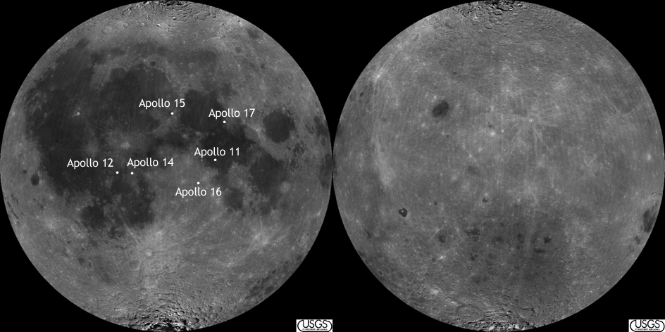
Fig. 1. Locations of the Apollo landing sites on the nearside of the Moon (left); the farside is at right. The Apollo seismic network occupied an approximate equilateral triangle, roughly 1200 km on a side, defined by the Apollo 15 site at the northern apex, Apollos 12 and 14 (close together at the SW apex), and Apollo 16 at the SE apex. The two Apollo heat-flow measurements were made at the Apollo 15 and 17 sites. No long-term geophysical measurements were made at the Apollo 11 site. Note the geographically restricted nature of these measurements.

The principal scientific importance of the Moon is as a recorder of geological processes active in the early history of terrestrial planets (e.g. planetary differentiation, magma ocean formation and evolution), and of the near-Earth cosmic environment (e.g. bombardment history, solar wind flux and composition) throughout Solar System history (e.g. Spudis 1996, Crawford 2004, NRC 2007). Some of these objectives are astrobiological in nature, in that they will enhance our understanding of the cosmic conditions under which life first arose on Earth (Crawford 2006). However, although the Clementine and Lunar Prospector missions have in recent years greatly added to our knowledge of the geochemical and mineralogical makeup of the lunar surface, our knowledge of the interior still largely relies on geophysical measurements made during the Apollo programme. As can be seen from figure 1, these landing sites are all located at low to mid-latitudes close to the centre of the lunar nearside, and were thus unable to provide anything approaching global coverage.

Mission Concept
In order to build on the Apollo data, and thus advance our knowledge of lunar science, the MoonLITE mission will place a number of instrumented penetrators into the lunar regolith for the purpose of conducting a range of in situ geophysical and geochemical measurements at widely separated localities.

The envisaged mission includes a Lunar Orbiting spacecraft that acts as both a carrier for the Penetrators and as a telecommunications relay. The descent to the lunar surface would require each penetrator to have an attitude control and de-orbit assembly.

The scientific payload for the penetrators will depend upon both the scientific requirements and technical feasibility within mass, power, communications and environmental constraints.

Penetrators
Penetrators are small probes which impact planetary bodies at high speed (e.g. up to 350 m/s) and bury themselves into the planetary surface. The impact process generates decelerations of up to 10,000g, which together with the low mass, restricts the type and capability of payload that can be accommodated. Penetrator technologies represent a novel challenge for space science and exploration.

Survival at these impact speeds has been demonstrated by ground tests of NASA DS2 and Japanese Lunar-A probes, and extensive defence-sector experience of impacts into materials mostly consisting of sand, concrete, steel and ice.

Current and Future Space Missions
Though there are several orbiter space missions either recently launched or with a launch expected in 2008 (SELENE, Chang’e, Chandrayaan-1, Lunar Reconnaissance Orbiter - LRO), none of these will be able to address the main science issues we propose that require a seismic network, or provide in-situ ground truth investigation of water/volatile deposits in the sub-surface lunar polar regolith. The Lunar Prospector impact produced no useful data about the Moon’s composition. The NASA LRO mission includes an impactor (LCROSS) with a flyby investigation of the resulting material thrown high up above the lunar surface. The deployment of multiple penetrators with MoonLITE will provide ground truth corroboration, and multi-site quantitative characterisation of any LRO and other mission results.

MoonLITE has the potential to provide exciting lunar science; provide information about the existence, concentration and form of any water ice deposits important for future lunar manned exploration; provide a confidence building technical demonstration of penetrator technology applicable to cost effective pre-cursor in-situ exploration of other solar system bodies; and enable development of a technical capability.

Science Requirements

Themes
The overarching questions that MoonLITE seeks to address are:

- How was the Earth-Moon system formed and what has been the evolution of the planetary environment at ~1AU?

- Are there volatiles within the permanently shaded polar craters and, if so what is their nature?

The top-level science objectives for MoonLITE fall into four categories: seismology, heat-flow, geochemical analysis, and polar volatile detection.

Lunar seismology
Seismology is the most powerful geophysical tool available to us for determining the interior structure of a planetary body. However, to-date the only object, other than the Earth, where it has been applied with some success is the Moon, where the Apollo missions deployed a network of highly sensitive seismometers close to the centre of the nearside. The Apollo seismometers remained active for up to eight years during which they provided important information on the Moon’s natural seismic activity, and the structure of the lunar crust and upper mantle (see Goins et al. 1981 and Lognonné 2005 for reviews). However, the deep interior of the Moon was only very loosely constrained by the Apollo seismology – even the existence, let alone the physical state and composition, of a lunar core remains uncertain.
The main problem was that the Apollo seismometers were deployed in a geographically limited triangular network (between Apollo 12/14, 15 and 16; Fig. 1) on the nearside. As a consequence, the information obtained on crustal thickness and upper mantle structure strictly only refers to the central nearside and may not be globally representative. Moreover, seismic waves capable of probing the deep interior had to originate close to the centre of the farside, and were therefore limited to rare, relatively strong, events. Indeed, the tentative seismic evidence for a lunar core arises from the analysis of just one farside meteorite impact that was sufficiently strong to be detected by more than one nearside Apollo seismic station in eight years of operation. This is clearly an unsatisfactory state of affairs, and there is a pressing need for a much more widely-spaced network of lunar seismic stations, including stations at high latitudes and on the farside. Penetrators delivered from orbit are ideally suited as a means of emplacing a global seismometer network, which would address the following scientific issues:

Requirement 1: To measure the size and physical state of lunar core
As the Apollo seismic data were unable to constrain the size or physical state of the lunar core, such knowledge as we have has been obtained from studies of the Moon’s moment of inertia, physical librations (as determined by laser reflector measurements), and electromagnetic induction studies (see Wieczorek et al. 2006 for a review). These studies favour a small (R<400 km) partially liquid core, with suggested compositions ranging from iron-nickel, Fe-FeS alloy, or molten silicates. Whether this liquid ‘core’ possesses a solid inner core is currently unknown. Information on the size, composition and physical state of a lunar core would have profound impacts on our understanding of the Moon’s origin, mantle evolution, and magnetic history. The latter point, when combined with studies of remnant magnetisation of surface rocks, will have important implications for our understanding of the origin and evolution of planetary magnetic fields. For these reasons, constraining the nature (and even the existence) of a lunar core is the top scientific priority of the penetrator-deployed seismic network.

Requirement 2: To determine the deep structure of the lunar mantle
One of the main contributions that lunar science can make to planetary science more generally is an enhanced understanding of the internal differentiation processes that occur immediately after the accretion of a terrestrial planet. Magma oceans are likely to have been a common phase in the early evolution of all rocky planets, and, in contrast to the more evolved mantles of the larger terrestrial planets, the structure of the lunar mantle may preserve a record of these early times. Seismology may help elucidate these processes in several ways.
Most fundamentally, seismology may be able to determine the initial depth of the magma ocean, and thus the fraction of the Moon’s volume that was initially molten. The Apollo data appear to indicate a seismic discontinuity at a depth of about 550 km, which is sometimes interpreted as the base of the magma ocean (see review by Wieczorek et al. 2006). However, because of the placement of the Apollo seismometers, it is not currently known whether this discontinuity is global in extent or exists only under the nearside. A competing explanation is that it represents the depth to which later partial melting has occurred which led to the formation of the nearside mare basalts. As noted by Wieczorek et al. (2006), distinguishing between these two possibilities is of key importance in understanding lunar mantle evolution.
In addition, measurements of seismic wave speed as a function of depth help constrain the mineralogy of the mantle (e.g. Lognonné et al., 2003). This in turn may be used to constrain both the bulk composition of the Moon (and thus its origin), and the crystallisation history of the lunar mantle and its implications for magma ocean evolution. Again, new, and more widely spaced, seismic data are now required if new advances are to be made over what has been learned from the Apollo data.

Requirement 3: To measure the thickness of the farside lunar crust
Reinterpretations of the Apollo seismic data have now constrained the thickness of the nearside anorthositic crust to about 30-40 km (Khan et al. 2002, Lognonné et al. 2003, Wieczorek et al. 2006). However, the thickness of the farside crust has not been constrained seismically at all. Estimates based on gravity data are typically in the range 70-90 km (Wieczorek et al. 2006), but these are non-unique, and in particular depend on whether the lunar highland crust should be considered as a single anorthositic layer, or as two layers with the lower layer having a more mafic (Fe-rich) composition. Farside measurements are required in order to determine the average lunar crustal thickness which, because of its very aluminium-rich nature, has significant implications for understanding the bulk composition (and thus origin) of the Moon.
In addition, there is considerable interest in the thickness of the crust (if any) remaining under the giant South Pole-Aitken (SPA) impact basin on the farside – the largest impact structure currently known in the Solar System. Together with the nearside Procellarum KREEP Terrain (well studied by Apollo) and the farside highlands, the floor of the SPA forms one of the three main lunar terrains identified by Jolliff et al. (2000). Part of the interest in the SPA lies in the possibility that it may have exposed lower crustal or upper mantle materials. Seismometers located within the SPA would, for the first time, be able to make a definitive measurement of the crustal thickness remaining under this important structure.

Requirement 4: To determine the origin of natural Moonquakes
The Apollo seismometers detected four types of natural Moonquake: (i) deep (700-1200 km), relatively weak, Moonquakes which occur in ‘nests’ and which appear to have a tidal origin; (ii) shallow (5-200 km), relatively strong, Moonquakes of unknown origin; (iii) thermal Moonquakes due to thermal stresses in the near surface; and (iv) meteorite impacts (summarised by Vaniman et al. 1991). Of these (i), (ii) and (iv) may be used as sources of seismic energy to probe the lunar interior, and a better understanding of the causes and clustering of (i) will provide additional knowledge of the physical properties of the deep lunar interior.
However, it is the shallow Moonquakes (ii) that are probably the most interesting scientifically. These were the strongest (up to magnitude 5) and rarest (only 28 recorded in 8 years), and currently their cause is unknown. Insofar as these result from unknown tectonic processes, our knowledge of present-day lunar geological activity will remain incomplete until their cause and locations can be identified (e.g. Nakamura 1979). Owing to the spatially restricted locations of the Apollo seismic stations, the Apollo data lacks the resolution to pinpoint the precise epicentres or depths of these events, for which a global distribution of seismometers will be required.
Understanding these events is also important in the context of future lunar exploration. For example, a magnitude 4-5 Moonquake is sufficiently strong that it would be prudent not to construct a lunar base at localities where they are likely to occur (Neal 2005). Some scenarios for future lunar exploration also envisage placing optical astronomical instruments on the lunar surface, and knowledge of lunar seismicity could be useful in deciding where to site such instruments. Thus, in addition to providing fundamental information about lunar geophysics, a better understanding of the origins and locations of shallow Moonquakes would make a significant contribution to future lunar exploration.

Lunar heat-flow

Requirement 5: To constrain the composition and thermal evolution of the lunar interior
Measurements of surface heat-flow provide valuable constraints on the composition and thermal evolution of planetary interiors. To date, the only planetary body other than the Earth for which surface heat-flow has been measured in situ is the Moon, during the Apollo 15 and 17 missions (Langseth et al. 1976). However, both these measurements were relatively close together on the nearside (Fig. 2) and may thus not be representative of the lunar heat-flow as a whole. Moreover, both these Apollo measurements have been subject to numerous re-interpretations over the years, owing to uncertainties in determining the thermal conductivity of the regolith, the extent to which the temperature sensors were in contact with the regolith, and the uncertain effects of local topography (both measurements were very close to highland/mare boundaries).
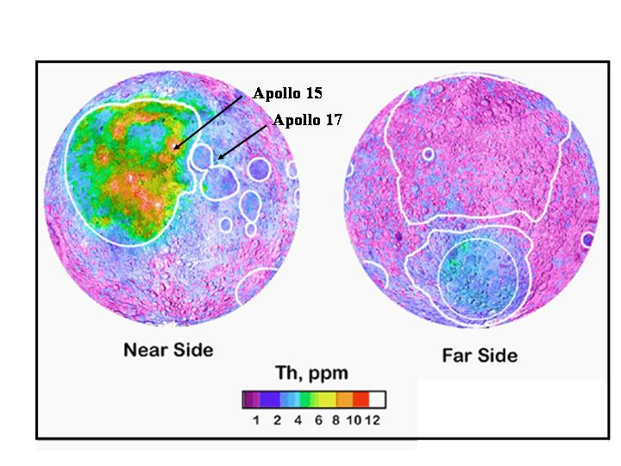
Fig. 2. Concentrations of Th in the lunar surface, measured by the NASA Lunar Prospector spacecraft. The PKT is the region of high Th concentrations around and to the south of the Imbrium basin on the nearside.

One particularly important measurement would be to determine the heat-flow as a function of distance from the Procellarum KREEP Terrain (PKT) on the north-western part of the lunar nearside. Remote sensing measurements have determined that the heat-generating elements (U, Th, K) are concentrated at the surface in this area of the Moon (Fig. 2), but a question remains over whether this is a surficial effect (owing to excavation of a global underlying layer of incompatible element-rich material by the Imbrium impact), or whether these elements are indeed concentrated in the mantle below the PKT. The latter scenario would predict a much higher heat-flow in the PKT than elsewhere, and would have major implications for our understanding of the early differentiation and crystallization of the Moon (e.g. Wieczorek and Phillips 2000). While the Apollo 15 and 17 data do appear to indicate a decrease in heat-flow away from the PKT (21±3 and 16±2 mW/m², respectively; Langseth et al. 1976), the experimental uncertainties are such that it is far from clear that this trend is statistically significant. In addition, Hagermann and Tanaka (2006) have drawn attention to fact that the Apollo results may simply reflect the different thicknesses of (U, Th, K-rich) Imbrium ejecta at the two Apollo sites, and not the underlying mantle heat-flow.
For all these reasons there is a pressing need to extend these measurements to new localities far from the Apollo landing sites (e.g. the polar regions and the farside highlands). Such measurements would greatly aid in constraining models of lunar thermal evolution. Finally, we note that in situ measurements of both the temperature and the thermal conductivity of the regolith in permanently shadowed polar regions (which would be inherent in any heat-flow measurement) would be valuable in constraining the possibilities for frozen volatiles, which are another of our key scientific objectives (see below). Penetrator deployment of a global heat-flow network would be an attractive means of achieving these objectives.

In situ geochemistry

Requirement 6: To characterise the geochemistry at diverse lunar sites
The only places on the Moon from which samples have been collected in situ are the six Apollo landing sites (Fig. 1) and the three Russian Luna sample return missions from near the Crisium basin on the eastern limb of the nearside. No samples have been returned from the polar regions or the farside, greatly limiting our knowledge of lunar geological processes. Although, statistically, many of the 90+ lunar meteorites must be derived from these unsampled regions, the provenance, and thus geological context, of any given meteorite is unknown, which limits their value in interpreting lunar geology.
Although sample return missions to a number of currently unsampled regions would be the preferred means of furthering our knowledge of lunar geological diversity, this may not be practical in the short term. An alternative would be to make in situ geochemical measurements, at least of the abundances of the major rock-forming elements (e.g. Mg, Al, Si, Ca, Fe and Ti). In addition to providing a great deal of information about the geology of the particular sites visited, such measurements would provide additional ‘ground truth’ for the calibration of remote-sensing instruments on forthcoming lunar orbital missions (e.g. Chandrayaan-1, SELENE, and LRO).

Polar volatiles

Requirement 7: To determine the presence, nature and origin of lunar polar volatiles
As is well known, the lunar Prospector neutron spectrometer found evidence for enhanced concentrations of hydrogen at the lunar poles, which has been widely interpreted as indicating the presence of water ice in the floors of permanently shadowed polar craters (Feldman et al. 1998). This potentially very important result is still awaiting confirmation, but if water ice is present it is most likely derived from the impacts of comets with the lunar surface (although solar wind implantation and endogenic sources might also contribute). The confirmation of water ice (and other volatiles) would be important for at least three reasons:

(i) Even though the original cometary volatiles will have been considerably reworked by impact vaporisation, migration to the poles, and subsequent condensation, it remains possible that some information concerning the composition of the original sources will remain. Among other things, this may yield astrobiologically important knowledge on the role of comets in 'seeding' the terrestrial planets with volatiles and pre-biotic organic materials (e.g. Chyba & Sagan 1992, Pierazzo & Chyba 1999).
(ii) As pointed out by Lucey (2000), lunar polar ice deposits may be of considerable astrobiological interest even if they do not preserve any vestigial information concerning their cometary sources. This is because any such ices will have been continuously subject to irradiation by galactic cosmic rays and, as such, may be expected to undergo ‘Urey-Miller-like’ organic synthesis reactions. Analogous reactions may be important for producing organic molecules in the icy mantles of interstellar dust grains, and on the surfaces of outer Solar System satellites and comets, but the lunar poles are much more accessible than any of these other locations.
(iii) The presence of water ice at the lunar poles would be a very valuable resource in the context of future human exploration of the Moon (as a potential source of oxygen, rocket fuel and drinking water). Confirmation of its presence would therefore make a significant contribution to the developing Global Exploration Strategy which has renewed human exploration of the Moon as a key element.
We consider that volatile detectors, deployed on penetrators and landed within permanently shadowed craters, would be a powerful and economical means of determining whether or not scientifically and operationally valuable deposits of volatiles exist at the lunar poles.

Lunar Exploration Requirements
Within the next few decades the Moon will see the renaissance of Lunar Exploration including manned exploration led by NASA. MoonLITE will provide important information within this context, particularly with regard to the environment at the lunar poles – where the first long duration manned outposts are likely to be located.

Requirement 8: To determine the presence and concentration of water ice in the permanently shaded craters

Requirement 9: To determine the natural seismic levels present at the lunar poles

Requirements Summary
The Science and Exploration requirements are summarized in table 1.

# | Requirement | Theme | Type
1 | To measure the size and physical state of lunar core | Earth-Moon System | Science
2 | To determine the deep structure of the lunar mantle | Earth-Moon System | Science
3 | To measure the thickness of the farside lunar crust | Earth-Moon System | Science
4 | To determine the origin of natural Moonquakes | Earth-Moon System | Science
5 | To constrain the composition and thermal evolution of the lunar interior | Earth-Moon System | Science
6 | To characterise the geochemistry at diverse lunar sites | Earth-Moon System | Science
7 | To determine the presence, nature and origin of lunar polar volatiles | Polar Volatiles | Science
8 | To determine the presence and concentration of water ice in the permanently shaded craters | Polar Volatiles | Exploration
9 | To determine the natural seismic levels present at the lunar poles |  | Exploration
Table 1. MoonLITE Science Requirements

References
Chyba, C.F., Sagan, C. Endogenous production, exogenous delivery and impact-shock synthesis of organic molecules: an inventory for the origins of life. Nature, 355, 125-132, (1992).
Crawford, I.A. Space Policy 20, 91-97, (2004).
Crawford, I.A. Internat. J. Astrobiol., 5, 191-197, (2006)
Feldman, W.C., et al. Fluxes of fast and epithermal neutrons from lunar Prospector: evidence for water ice at the lunar poles. Science, 281, 1496-1500, (1998).
Goins, N.R., Dainty, A.M., Toksoz, M.N. lunar seismology – the internal structure of the Moon, J. Geophys. Res. 86, 5061-5074, (1981).
Hagermann, A. and Tanaka, S. Ejecta deposit thickness, heat-flow, and a critical ambiguity on the Moon. Geophys. Res. Lett., 33, L19203, (2006).
Jolliff, B.L., Gillis, J.J., Haskin, L.A., Korotev, R.L., Wieczorek, M.A. Major lunar crustal terranes: surface expressions and crust-mantle origins. J. Geophys. Res. 105(E2): 4197-4216, (2000).
Khan, A. An inquiry into the lunar interior – a non-linear inversion of the Apollo seismic data. J. Geophys. Res, 107, 1-23, (2002).
Langseth, M.G. et al. lunar Planet. Sci. Conf., 7, 3143-3171, (1976).
Lognonné, P. Planetary Seismology, Ann. Rev. Earth. Planet. Sci., 33, 571-604, (2005).
Lognonné. P., et al. A new seismic model of the Moon: implications for structure, thermal evolution and formation of the Moon. Earth. Planet. Sci. Lett., 211, 27-44, (2003).
Lucey, P.G. Potential for prebiotic chemistry at the poles of the Moon. Proc. SPIE, 4137, 84-88, (2000).
Nakamura, Y., et al. Shallow Moonquakes: depth, distribution and implications as to the present state of the lunar interior. Proc. lunar Planet. Conf., 10, 2299-2309, (1979).
Neal. C.R. The importance of establishing a global lunar seismic network. Paper presented at the 2005 Space Resources Roundtable, Abstract #2065, (2005).
NRC. The Scientific Context for Exploration of the Moon - Final Report, National Research Council, Washington D.C, (2007)
Pierazzo, E., Chyba, C.F. Amino acid survival in large cometary impacts. Meteorit. Planet. Sci., 34, 909-918, (1999).
Spudis, P.D. The Once and Future Moon, Smith. Inst. Press, (1996).
Vaniman, D., et al. The lunar environment. In: The lunar Sourcebook, CUP, pp 27-60, 1991.
Wieczorek, M. A and Phillips, R. J. J. Geophys. Res., 105(E8) 20,417-20,430, (2000).
Wieczorek, M.A., et al., New Views of the Moon, Rev. Min. Geochem., 60, 221-364, (2006).

