How big is the Moon?

Objectives

- Students use simple ratios to calculate the size of the Moon.

------------------------------------------------------------------------------

Resources required

Per student:

- meter rule
- card
- hole puncher or scissors.

-------------------------------------------------------------------------------

Teaching activities

Introduction

This activity could be set as homework over the winter term. Check when the Moon is visible in the evening. The Moon phases can be found on the website http://www.heavens-above.com/. Go on as an anonymous user and select your location. Look for the Moon under ‘Sun and Moon data for today’ to get the up and coming phases.

In this exercise the students will calculate the size of the Moon from how big it appears to be in the sky. As an introduction ask the students to hold their thumb up at arm's length in front of them. Imagine lines from either side of your thumb to a point on the pupil of your eye. The angle formed by these two lines is a kind of measure of the width (diameter) of your thumb, known as the angular diameter. Hold your thumb up at arm's length again, and move it closer to your eye. What happens to the angular diameter? As you can see, the value of an object’s angular diameter depends upon the distance from the observer to the object. The students are going to use this same idea to measure the diameter of the moon.

Activities

The first part of the activity should be carried out in the classroom. Cut or punch a hole in the upper centre of the card and a rectangular hole below. The rectangular hole needs to be large enough to fit over the metre rule as shown in the image below.

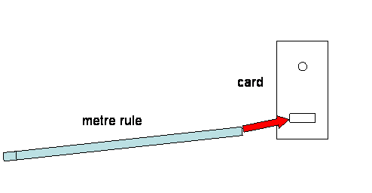

The next part needs to be carried out at home in the evening when the Moon is visible and near full. The student may need to be accompanied by a parent.

The student should hold the metre stick with the zero end touching their cheek and point the stick at the moon. Then slide the card back and forth along the meter rule, until the Moon exactly fills the hole in the card. This is easier if done in pairs; one person holding the meter rule and the other moving the card. Also, it may be helpful to close one eye when looking through the hole.

Once satisfied that the Moon exactly fills the hole, read the distance of the card along the metre rule.

The next part of the activity should be done either for homework or back in the classroom.

There is a simple mathematical law which says:

A = X
B Y

A
B
X
Y

In this situation:

A = width of the hole
B = distance of card from the eye
X = diameter of the Moon
Y = distance to the Moon

You can now work out the diameter of the moon using the following ratio:

width of hole diameter of Moon
------------------------ = ------------------------
distance of card from eye distance to the Moon

Use the distance to the Moon as 400,000 km (the accepted value is 384,400 km).

Summary exercises

Reveal the students’ calculated values and determine the mean value.

