CD Spectrometer

Objectives

- Students build a basic spectrometer.
- Students use their spectrometer to look at several light sources.
- Students understand that the wavelength of light given off by something can tell us what it is made of.

------------------------------------------------------------------------------

Resources required

Per student:

- empty cereal box
- CD
- sellotape
- scissors

-------------------------------------------------------------------------------
Teaching activities

Introduction

In this activity students work in pairs or individually to make a spectrometer, one of the most common instruments used in space research. They can then use them to analyse the light coming from a fluorescent light and the solar spectrum coming from the sky. Scientists use spectrometers to learn about distant objects in the Universe.

Activities
Take an empty cereal box and cut a slot on one of the long sides near the end. Make the slot at a 45° angle. (If using scissors it is easier to cut the box if you squeeze the two sides of the corner together).

Cut a slit 1mm wide on the other side of the box directly opposite the middle of the diagonal slot. This will be the “entrance aperture”, the bit that you point at the light you want to analyse.

On the short edge nearest the slot cut a *SMALL* hole that enables you to look at the CD. (If you make a small piercing first with a pencil/pen cutting is easier).

Apart from this, the rest of the box needs to be as light-tight as possible, so tape the other sides tightly shut.

Summary exercises

Next, the students can take their spectrometers and look at the sky *BUT NOT DIRECTLY AT THE SUN!* (or they can cause permanent damage to their eyes). It is easiest to point the spectrometer at a cloud. They should see that the Sun’s light is made up of all the colours in the rainbow but also has many black lines in it, like below.
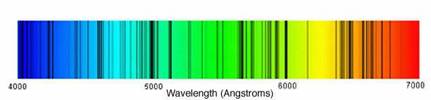

The dark lines are called the Frauenhofer lines and are caused by atoms in the solar atmosphere absorbing light emitted from the surface, blocking it from reaching the Earth. Each element has a distinct "fingerprint" of lines by which it can be identified. So, atoms of a particular element absorb light of a very specific wavelengths. The element Helium was discovered in the Sun’s atmosphere (the name coming from the Greek word for the Sun helios.

Next, the students can use their spectrometer to look at the light coming from a fluorescent light. Instead of a full rainbow, they should see only a few lines. Each line corresponds to a different element, so the exact spectrum you see depends on what kind of light you have. Most likely you have one that looks like this…

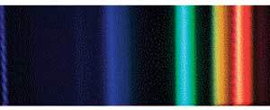

The brightest peaks are in the green and the orange. By measuring the exact wavelength of these peaks, we can work out which elements are giving off the light. In this case, the green line is given off by mercury, and the orange is given off by an element called Europium (look for it on the periodic table, symbol: Eu, atomic number: 63, it’s one of the lanthanides.)

