What are impact craters?

Objectives

There are 2 parts to this activity.

Students will:

- Identify features produced by the cratering process.
- Study craters seen on the Moon.
- Create a model crater in the classroom.

------------------------------------------------------------------------------

Resources required

- Images of craters on the Moon (images supplied in this document are courtesy of NASA)
- Labelled image of a crater on the Moon (supplied)
- Plasticene or modelling clay

Teaching activities

Introduction
In this activity students will study the features of craters and then make a model using plasticene or modelling clay. Craters are observed in the Solar System, most noticeably on the surface of the Moon. Craters have been studied in great detail and are important as they tell us about the history of the Solar System and about the properties of the bodies involved in the impact.

Activity 1: observing craters
Split the students into groups or pairs and hand out or display the images of craters on the Moon (supplied below and courtesy of NASA). Ask the students to discuss the craters and think about:

- Common features of the craters.
- What formed the craters?

Then display and go over with the class the labelled image of a crater and discuss the following common features:

- Crater floor. This area is lower than the surrounding ground as materials has been ejected and is flat or bowl-shaped. Some times the crater can be filled with lava if the impact breaks through the lava below the surface.
- Wall. Very steep and could have giant steps in them which are called terraces.
- Raised rim. Some of the material thrown out of the crater is deposited as a pile of debris that forms a ring around the edge of the crater/
- Ejecta. Material that is ejected during the impact forms a blanket around the crater. The ejecta become thinner further away from the crater.
- Rays. Around some craters are seen bright streaks, extending for great distances.

The larger craters also have a central uplift; a mountain in the centre of the crater. These only occur in craters larger than 40 km in diameter. These are material ejected from the crater.

Craters are formed by impacts of large objects (pieces of rock and metal), varying in size and velocity. Such impacts were common in the early days of the Solar system’s history, when it was just forming and the material which did not come together to form the planets and the Sun was left as ‘space debris’. Today impacts are less common but are still seen, for example the comet Shoemaker-Levy which crashed into Jupiter in 1994.

Common crater features

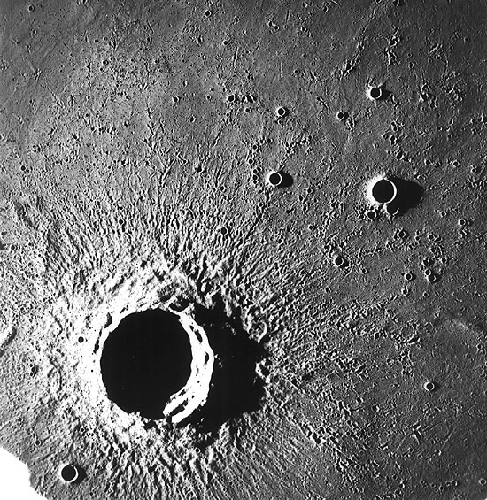
Wall
Floor
Rays
Ejecta
Raised rim

Image of a crater on the Moon (courtesy of NASA)

Activity 2: making craters with plasticene or clay

Now that the students know the features of an impact crater they should create one using plasticene or modelling clay.

