

MEMORANDUM

SWIFT Observation Definition

410.4-AGMT-0011

REVISION – 0.0

DATE 16 October 2002

Goddard Space Flight Center
Greenbelt, Maryland

Table of Contents

1 Introduction 6
1.1 Purpose 6
1.2 Applicable Documents 6
2 Revisions 6
3 Observation 7
3.1 Observation strategy 7
3.2 Snapshot, Observation, and Monitoring 7
4 Terminology 9
5 Target ID & Observation Segment 10
5.1 Type of targets 10
5.2 Target ID Number Allocation 10
5.3 Observation segment 12
6 Observation number /Sequence Number 13
7 Notes 14
7.1 Other considerations 14
7.2 Special Circumstance and Open Issues 15
8 Appendix 18

Signature Page

Prepared by:
Lorella Angelini (HEASARC) Date

Prepared by:
Francis E. Marshall (Swift GNEST Leader) Date

Reviewed by:
Richard Fink (SDC ) Date

Reviewed by:
Margaret Chester (Swift MOC Leader) Date

Reviewed by:
Dave Burrows (Swift XRT Leader) Date

Reviewed by:
Peter Roming (Swift UVOT Leader) Date

Reviewed by:
Scott Barthelmy (Swift BAT Leader) Date

Reviewed by:
Doug Spiegel (Omitron Leader) Date

Reviewed by:
David Bundas (Swift Systems Engineer) Date

Approved by:
Francis E. Marshall Date

CHANGE RECORD PAGE (1 of 2)

DOCUMENT TITLE :Memorandum Swift Observation definition
DOCUMENT DATE: 16 October 2002
ISSUE | DATE | PAGES AFFECTED | DESCRIPTION
DOCUMENT TITLE: Memorandum swift Observation definition

RELEASE DATE: 16 October 2002
LIST OF AFFECTED PAGES

Page No. | Revision | Page No. | Revision | Page No. | Revision

- Introduction

  - Purpose

This document describes the overall concept of observation for the Swift mission and defines the numbering scheme adopted for the Observation number/Sequence number, Observation segment and Target ID. These values are used on board and by many of the ground segment groups for planning purposes, during the processing and data archive. This document contains:
- Overall description of the Swift observing strategy for GRB
- Definition of Target ID, Observation segment and Observation number/Sequence number
- Description of the numbering scheme for the above listed quantities
- Description on the usage of the above definition
- List of the applicable subsystems where these definitions are used

  - Applicable Documents

The requirements contained in this memorandum were derived from the following documents:
- Swift Proposal AO-98-OSS-03 (August 1998)
- Swift Phase A report (September 1999)
- Requirements of the Ground System for the Swift Mission (Sep 2000)
- GCN and Swift (June 2001)
- Onboard Operational Messaging Interface, 410.4-ICD-0006 (June 2001)
- TDRSS Message Archival Plan 6/22/00
- Target ID Final Memo (e-mail message 6/06/01)
- MOU: Swift-HEASARC 410.4-PROC-0016 (August 2001)
- ICD MOC-SDC (October 2001)
- Swift spacecraft to payload telecommand ICD (6 June 2001)

- Revisions

Revisions to this document will be controlled by the GNEST Configuration Control Board (CCB).
- Observation

  - Observation strategy

The Swift operations are different from previous conventional missions where a pre-determined observing program, based on known positions, is followed unless interrupted by TOOs. Conventional missions organized data by observation where an observation is typically an ‘un-interrupted’ long look at the same sky position. An observation is identified by a unique label or number. Monitoring campaigns are accommodated within this scheme by typically assigning a different label for each look.
There are several science projects that can be derived from the Swift observations. The main science is to detect and follow-up the evolution of a GRB/afterglow. The Swift observation strategy is mainly driven by this requirement.
The typical Swift observing strategy for a Gamma Ray Burst (GRB)/afterglow consists of a cluster of snapshots aimed to follow the GRB and its afterglow evolution. Soon after an event is triggered by the BAT, the Figure of Merit (FOM) algorithm, part of the observatory’s autonomy, decides if it is worth requesting a slew maneuver to point the narrow field instruments (NFIs) on Swift (XRT and UVOT) in the direction of the trigger. The initial follow-up is automatically set at the spacecraft level, e.g., the FOM initiates the observation using a “standard” configuration of modes and filters for the NFI. Observations of GRBs can be also triggered by ground command based on observations with other satellites.
Once the trigger is known (either from Swift or from other satellites), from the ground a monitoring schedule is planned and uploaded. The monitoring of the GRB/afterglow will typically be initiated as soon as possible after its detection and last until the afterglow reaches a specified minimum flux or until a specified time has elapsed. It is also possible that Swift abandons the follow-up of a particular trigger because other targets are deemed to be more interesting.
Swift also plans to observe targets other than GRBs, e.g., previously known sources or new transient, while for example waiting to observe a new GRB/afterglow. The observing strategy in this case may be different, but the monitoring pattern is maintained.

  - Snapshot, Observation, and Monitoring

The Swift observing strategy can be defined by three fundamental time-scales:
- The minimum unit time on a target is a snapshot. This is defined as the time spent observing the same position contiguously. Because of observing constrains, the length of these snapshots is therefore shorter than a single orbit. The snapshot is interrupted either because of a new intervening trigger or because the time allocated ends. Instrument configurations, such as mode and/or filter, can change during a snapshot.

- An observation is a cluster of snapshots designed to carry out a particular set of scientific goals via a series of instrument mode configurations. Given the nature of the NFIs, this will almost always be a sequential set of snapshots on the same target. The Roll angle within an observation is kept constant. An observation will be interrupted by observation of different targets, because of the observing constraints of the NFIs. Each observation will have an “observation configuration”. This consists of a series of instrument configurations. For the UVOT this would detail the sequence of observing modes, filters, and durations of each of these modes. The “observation configuration” will be specified only at the start of each observation. The length of an observation can vary. However to allow a quick delivery of data to the community an observation have a limited duration in time of a maximum of 2 (TBR) days. An observation is processed only when all data for that observation are available.

- Depending on the evolution of the flux, the sensitivity of each instrument, and the required science, the same target may be observed several times. The collection of observations on a specific target constitutes the monitoring campaign. The roll angle can change among the observations part of a monitoring campaign. There is no maximum time set for the monitoring of a target nor for the number of observations per target. However it is expected for most cases that a GRB target is monitored for about a month.

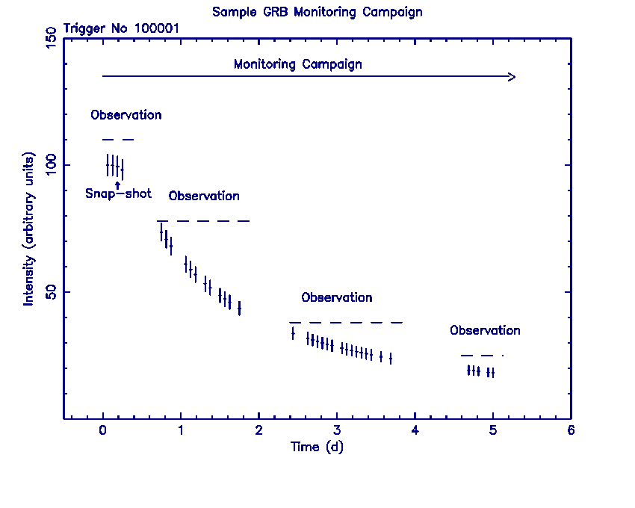
Figure 1. A sample GRB monitoring campaign showing snapshots and observations.

- Terminology

The software requirement document for the FOM includes two numbers that will be provided to each of the instruments for every observation. The first identifies the target being observed, hereafter Target ID, and therefore it is unique to an object. The second numbers the observations part of the monitoring campaign on a specific target, hereafter Observation segment. The Target ID is a 24-bit number, and the Observation segment is an 8-bit number. The instruments will tag their science data in the telemetry with this 32-bit number where the most significant 8-bits represent the Observation segment, and the least significant 24 bits are the Target ID. This representation is named hereafter Observation number and given as a HEX value. The decimal representation of the 32-bit number is used instead to tag the data in the archive, in all the database tables associated with the data and in the as-flown timeline. The decimal representation of the 32-bit number is named hereafter Sequence number .

- Target ID & Observation Segment

  - Type of targets

The main science goal of Swift is to detect GRBs, which by their nature are previously unknown sources. Each GRB is assigned a unique Target ID used during the monitoring campaign for that specific GRB/afterglow. However there are many different types of targets that need to be considered. There are:
- GRBs detected on board with BAT. These are GRB triggers that the BAT software considers to be valid (by whatever criteria).
- Known sources included in the BAT on-board catalog. Transient event from one of these sources maybe detected with BAT and can lead to an observation. Initially this information will be sent to the ground for evaluation, but later in the mission observations may be initiated without ground intervention.
- New Transients discovered with BAT. These are sources not in the on-board BAT catalog. Initially this information will be sent to the ground for evaluation, but later in the mission observations may be initiated without ground intervention.
- GRBs discovered with other missions that are loaded as TOOs from the ground.
- GRBs found in the BAT data, but not discovered on-board.
- Non-GRB observations (e.g., TOOs) loaded from the ground.
- Calibration observations. These are loaded from the ground.
- Planned non-science observations (e.g., spacecraft activation).
- Data obtained pre-launch.
- Data obtained during safe hold or safe point
The goal is to assign a Target ID to all Swift observations and to have a unique Target ID associated with every Swift target (whether or not it is a GRB). Further the Target ID will identify the type of target.

  - Target ID Number Allocation

There are 2²⁴ (16777216) possible Target ID numbers. The Target ID numbers are allocated in slots of 10^{N}. The scheme is the following:

0-999
- 0: This is reserved for the spacecraft. It will be assigned whenever the spacecraft is in safehold. It may also be assigned whenever the spacecraft fails to assign a number.

- 1-6: Used for safe pointings. It is assigned on-board by the spacecraft, but a new Target ID will be assigned during ground processing.

- 7-999: These are reserved for the spacecraft. They are currently not planned to be used.

1000-9999: Unassigned

10000-99999:

- 10000-19999: Reserved for the BAT catalog. This includes known sources. The triggers based on flux variations of known sources will use as Target ID the number assigned to those sources.
- 20000-29999: GRBs discovered with other missions or from BAT data during the ground analysis that are not associated with a trigger number. These numbers are assigned by the ground and sent to the spacecraft when an observation of the source is requested. (If ground analysis of a BAT trigger, not validated by the on board software as a good, reveals that there was actually a valid GRB, follow-up observations will use the original trigger number.)
- 30000-39999: Non-GRB observations (TOOs and other targets) uploaded from the ground.
- 40000-49999: Reassigned Target ID for safe pointing. At each time during the mission there are only 6 sky positions loaded on board with Target ID values ranging between 1-6. However, these 6 sky locations for the safe pointing can change during the mission, and therefore the 1-6 Target ID values are not sufficient to distinguish all the possible safe pointing locations. To remove the degeneracy, on ground the safe pointing positions have their Target ID reassigned.

- 50000-59999: Calibration observations. These values are assigned to calibration observations performed during the mission. The calibration targets can be already included in other subgroups of Target ID; e.g., they may be already listed as a target in the BAT catalog.

- 60000-69999: Non-science observation such as activation. These observations are expected to be done mainly during the beginning of the mission.

- 70000-79999: Pre-launch data. These targets are assigned to the calibration ‘observations’ performed on ground by the different instruments and by the spacecraft. Since the instruments and the spacecraft operate separately on the ground the number allocation has been subdivided as follows:

- 70000-70899 : Pre-launch allocated to the spacecraft for calibration
- 70900-70999 : Pre-launch allocated to the spacecraft for testing

- 71000-71899 : Pre-launch allocated to the BAT for calibration
- 71900-71999 : Pre-launch allocated to the BAT for testing

- 72000-72899 : Pre-launch allocated to the UVOT for calibration
- 72900-72999 : Pre-launch allocated to the UVOT for testing

- 73000-73899 : Pre-launch allocated to the XRT for calibration
- 73900-73999 : Pre-launch allocated to the XRT for testing

- 74000-75999 : Pre-launch allocated to the BAT simulation

- 80000-99999: Unassigned

100,000-16,777,214:
BAT triggers. BAT generates these numbers in sequence when a trigger occurs. This is the largest numbering allocation because it is expected that most of the Swift targets should be BAT detected GRBs. Note that a Target ID is assigned to every BAT trigger even if they are judged on board not to be a good GRBs. These numbers are also used for triggers that result in a detection of a new non-GRB BAT transient. There should be very few of these. When follow-up observations are planned, the ground assigns the same number that BAT generated.

16,777,215 (=$FFFFFF) :
Reserved to indicate that the reporting subsystem does not know the correct target ID.

  - Observation segment

To each observation part of a specific target monitoring is assigned on board an observation segment number. The value is therefore unique for every observation of a given target. There are 2⁸ (256) possible observations that can be performed for a given target. The first time on a specific target is given the number 1, and this number is incremented for each subsequent observation. It is the responsibility of whichever subsystem initiates the observation to provide the correct observation segment. For most targets, the first observation will be initiated by a BAT detection of a GRB, and subsequent observations will be scheduled from the ground. In this case, BAT is responsible for providing the first number for the observation segment with the value 1, and the ground is responsible for generating the subsequent observations segment numbers (2, 3, ...). If the first observation is not initiated on board, then it is the ground’s responsibility to assign the first number for the observation segment with the value of 1. The number allocation for the observation segment is the following:

- 0: Reserved to indicate that all observation segment values for this target will be 0. It is likely that the spacecraft will always assign an observation segment value of 0.

- 1: Used for the first observation of a target.

- 2-253: Available to subsequent observations of a target.

- 254: BAT good trigger not followed by a slew.
- 255 ($FF):To indicate that the reporting subsystem does not know the correct observation number

- Observation number /Sequence number

Every moment of the mission has associated an observation and every observation is tagged by an observation number. The observation number is the 32-bit concatenation of the Target ID and the observation segment. The sequence number is the decimal representation of the 32-bit with the following syntax. It is always an 11 digit number, where the first 8 digits are for the Target ID and the remaining 3 digits for the observation segment. Leading zeros are used to maintain the length fixed at 8 digits for the Target ID and 3 digits for the Observation segment. An example is shown in Figure 2, where the Target ID is 100001, corresponding to the first trigger by the BAT, and the observation segment is 2, corresponding to the second observation on that target. In this case the sequence number is:
‘ 00100001002’
The concatenation of the 32-bits, observation number, is in HEX 020186a1.
An observation is tagged with the observation number and the data corresponding to that observation are identified within the archive and in all the database tables and in the as flown timeline with the corresponding sequence number.
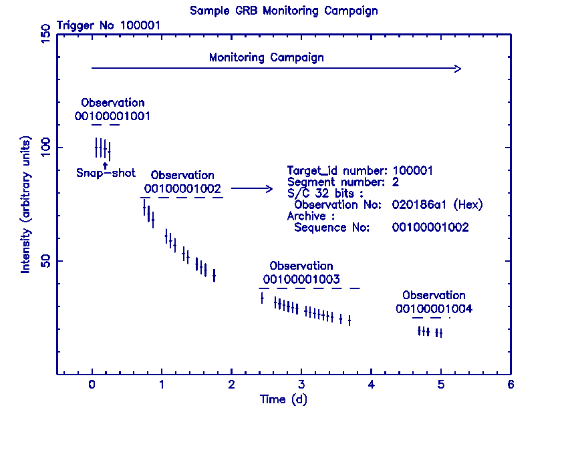
Figure 2. A sample monitoring campaign with trigger (target ID), segment, observation and sequence numbers.

- Notes

  - Other considerations

For preplanned targets, the Target ID and observation segment are set by the MOC. This information will be part of the commands to perform the observation. For BAT-detected automated targets, the BAT instrument will assign the Target ID and observation segment. The Target ID should start at some default value (100,001 in the scheme suggested above) and be equal to the BAT trigger number. The observation segment should be 1 for automated targets.

For TOOs, the ground will assign the Target ID and the observation segment. The ground needs to keep track of previously observed targets so that unique Target IDs and observation segment values are used. The ground is also responsible for assigning Target IDs and observation segment values for calibration observations and activation. The spacecraft initiates safe pointings, but the ground is responsible for reassigning the Target ID to remove the degeneracy in the Target ID values reserved for safe pointings. Safe holds are also initiated by the spacecraft, but it is unlikely that any science data will be generated during these “observations”.

  - Special Circumstance and Open Issues

There are a few situations that require a special effort to maintain a unique ID for every target. In some (hopefully rare) cases the ground will have to fix things.

- BAT produces telemetry such as TDRSS messages and event-by-event data in response to each trigger. Some of these data, such as the event-by-event data, can be suppressed for invalid triggers. It is expected that this suppression will be used during normal operations, but event-by-event data will be produced for every trigger during part of on-orbit check-out. The last trigger number will be incremented and assigned as the Target ID for this telemetry. If the trigger is produced by a known source (such as Cyg X-1 or a previous GRB), this will produce data with at least two Target IDs for that source. This will need to be corrected on the ground.
- Updates to the BAT catalog may create the opportunity for multiple IDs of the same target. Each catalog entry includes a value for the associated Target ID. New entries may have already had Target IDs assigned to them because of BAT triggers or Swift TOOs. It is the responsibility of those updating the catalog to provide the correct Target ID. Note that this means that some catalog entries will not have Target IDs in the range assigned to the BAT catalog.
- A new Target ID will have to be assigned in the observation segment number exceeds 253. Fortunately this is expected to be very rare.
- Calibration sources may have already been assigned a Target ID outside the range allocated to calibration sources. It is not clear which Target ID should be assigned. This is an open issue.

- If at some point Swift responds automatically to transients from
- known sources, it may not be possible to keep track of the
- observation segment over the whole mission. In this case the observation segment will have to be fixed on the ground

Typically at any one time all three instruments will be tagging their data with the same observation number, but this is not true near a burst trigger. There are two cases to consider depending on whether the spacecraft quickly slews to observe the newly detected target. BAT will always produce data tagged with the new trigger number. The NFIs will produce data tagged with the new trigger number if the spacecraft slews to the new target. If there is no slew, BAT will change its observation number to agree with that of the NFIs after it has produced the data associated with the new trigger. Figures 3 and 4 show these sequences graphically.

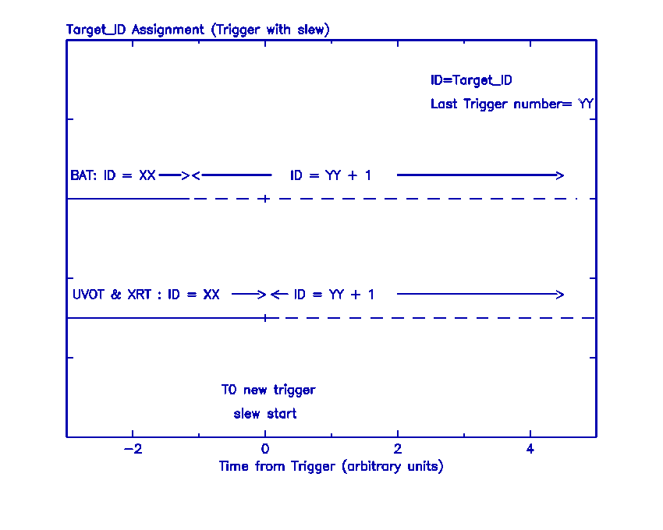

Figure 3. The sequence of Target IDs when a trigger is followed with a slew.
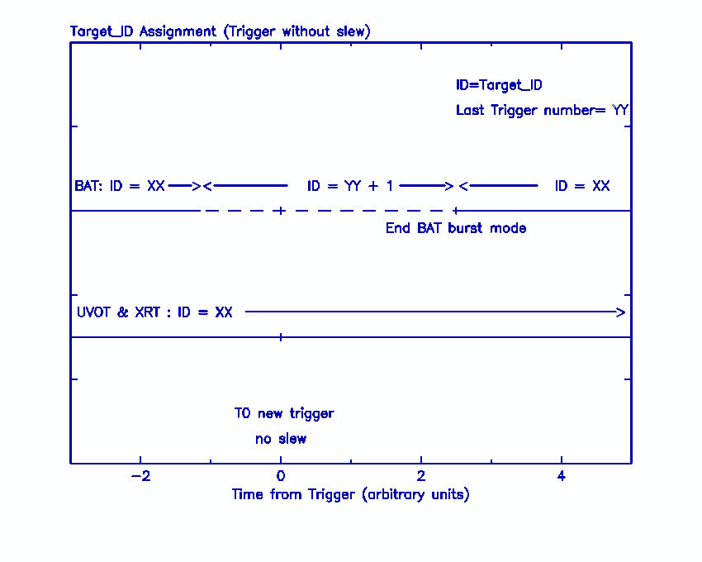

Figure 4. The sequence of Target IDs when a trigger is not followed with a slew.

- Appendix

Summary table for numbering the Target ID. See section 5.2 for full description.
0 | Reserved for the spacecraft : safehold or spacecraft fails to assign a number.
1-6 | Used for safe pointings.
7-999 | Reserved for the spacecraft. Currently not planned to be used.
10000-19999 | Reserved for the BAT catalog (known sources). The triggers based on flux variations of known sources will use as Target ID the number assigned to those sources.
20000-29999 | GRBs from other missions or discovered from ground analysis of BAT data.
30000-39999 | Non-GRB observations (TOOs and other targets) uploaded from the ground.
40000-49999 | Reassigned Target ID for safe pointing. The reassignment occurs on ground to remove the degeneracy of the several sky positions used for safe pointing for which only 6 Target ID are available and assigned on board.
50000-59999 | Calibration observations performed during the mission. The calibration targets can be already included in other subgroups of Target ID.
60000-69999 | Non-science observation (mainly used at the beginning of the mission).
70000-79999 | Pre-launch calibration ‘observations’. Since on ground instruments and spacecraft operate separately the number allocation has been subdivided as follows:
70000-79999 | 70000-70899 | Pre-launch allocated to the spacecraft for calibration
70000-79999 | 70900-70999 | Pre-launch allocated to the spacecraft for testing
70000-79999 | 71000-71899 | Pre-launch allocated to the BAT for calibration
70000-79999 | 71900-71999 | Pre-launch allocated to the BAT for testing
70000-79999 | 72000-72899 | Pre-launch allocated to the UVOT for calibration
70000-79999 | 72900-72999 | Pre-launch allocated to the UVOT for testing
70000-79999 | 73000-73899 | Pre-launch allocated to the XRT for calibration
70000-79999 | 73900-73999 | Pre-launch allocated to the XRT for testing
70000-79999 | 74000-75999 | Pre-launch allocated to the BAT simulation
80000-99999 | Unassigned
100,000-16,777,214 | BAT triggers. Target ID is assigned to every BAT trigger even if they are judged on board not to be a good GRBs. These numbers are also used for triggers of a new non-GRB BAT transient. For follow-up observations, the ground assigns the same number that BAT generated.
16,777,215  (=$FFFFFF) | Reserved to indicate that the reporting subsystem does not know the correct target ID.

