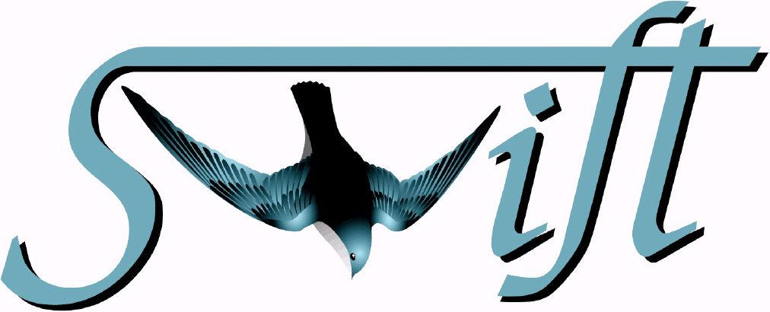
UVOT Launch & Early Orbit Timeline
and Turnon Procedure

SWIFT-UVOT-040

Author: Pete Roming

Version 1.1

Date: 8 April 2003
Rev: 28 January 2004

Approved by: | Signature | Date
Pete Roming, PSU
UVOT Lead
Phil Smith, MSSL
ICU Software Engineer
Keith Mason, MSSL
UVOT-TM Principal Investigator
John Nousek, PSU
Narrow Field Instruments Lead
Margaret Chester
MOC Lead
Frank Marshall
Ground Systems Lead

REVISION SUMMARY

REV | RELEASE DATE | BRIEF DESCRIPTION/REASON FOR CHANGE | EFFECTED PAGES
0.0 | 8 April 2003 | Draft copy for comments. | All
0.1 | 14 April 2003 | Included comments from Scott Koch and Phil Smith. | All
0.2 | 24 April 2003 | Included changes from Pat Broos. | 5, 9-11
1.0 | 30 April 2003 | Initial release incorporating changes from OAWG meeting. | All
1.1 | 28 January 2004 | Minor changes based on the mission L&EO timeline and comments from Phil Smith | 8-10

Initial Conditions

Check the following:

- 5 S/C UVOT temperature sensors
- 3 Door microswitches (Telescope door and latches closed)
- Survival heaters on

Do the following:

- Open ITOS archives for UVOT

Time | Event | Observatory Status | Telecommands | UVOT Activities | Ground Activities | Comments
L+5 days  (2 orbits) | Power on Redundant DEM | Malindi contact | Start uvot_dem_commissioning | Enable 1553, power on DEM, check ICU & DPU watch dog, perform time test, test SSI, test EEPROM, & place DEM in SAFE state | Monitor DEM startup, current, interface test messages, HK, & verify that DEM is in SAFE state | Verify correct telemetry before continuing. Since TM is not powered expect TM related HK to have Red Limits
L+5d | SAFE state | TDRSS contact |  | Monitor pointing constraints & slews | Monitor HK & verify that DEM is in SAFE state | Verify that all HK values are nominal
L+6d | SAFE state | TDRSS contact |  | Monitor pointing constraints & slews | Monitor HK & verify that DEM is in SAFE state | Verify that all HK values are nominal
L+7d | SAFE state | TDRSS contact |  | Monitor pointing constraints & slews | Monitor HK & verify that DEM is in SAFE state | Verify that all HK values are nominal
L+8d | SAFE state | TDRSS contact |  | Monitor pointing constraints & slews | Monitor HK & verify that DEM is in SAFE state | Verify that all HK values are nominal
L+9d | SAFE state | TDRSS contact |  | Monitor pointing constraints & slews | Monitor HK & verify that DEM is in SAFE state | Verify that all HK values are nominal
L+10d | SAFE state | TDRSS contact |  | Monitor pointing constraints & slews | Monitor HK & verify that DEM is in SAFE state | Verify that all HK values are nominal
L+11d | SAFE state | TDRSS contact |  | Monitor pointing constraints & slews | Monitor HK & verify that DEM is in SAFE state | Verify that all HK values are nominal

Time | Event | Observatory Status | Telecommands | UVOT Activities | Ground Activities | Comments
L+12d | SAFE state | TDRSS contact |  | Monitor pointing constraints & slews | Monitor HK & verify that DEM is in SAFE state | Verify that all HK values are nominal
L+13d | SAFE state | TDRSS contact |  | Monitor pointing constraints & slews | Monitor HK & verify that DEM is in SAFE state | Verify that all HK values are nominal
L+14d | SAFE state | TDRSS contact |  | Monitor pointing constraints & slews | Monitor HK & verify that DEM is in SAFE state | Verify that all HK values are nominal
L+15d | SAFE state | TDRSS contact |  | Monitor pointing constraints & slews | Monitor HK & verify that DEM is in SAFE state | Verify that all HK values are nominal
L+16d | SAFE state | TDRSS contact |  | Monitor pointing constraints & slews | Monitor HK & verify that DEM is in SAFE state | Verify that all HK values are nominal
L+17d | SAFE state | TDRSS contact |  | Monitor pointing constraints & slews | Monitor HK & verify that DEM is in SAFE state | Verify that all HK values are nominal
L+18d | SAFE state | TDRSS contact |  | Monitor pointing constraints & slews | Monitor HK & verify that DEM is in SAFE state | Verify that all HK values are nominal
L+19d | SAFE state | TDRSS contact |  | Monitor pointing constraints & slews | Monitor HK & verify that DEM is in SAFE state | Verify that all HK values are nominal
L+20d | SAFE state | TDRSS contact |  | Monitor pointing constraints & slews | Monitor HK & verify that DEM is in SAFE state | Verify that all HK values are nominal
L+21d | SAFE state | TDRSS contact |  | Monitor pointing constraints & slews | Monitor HK & verify that DEM is in SAFE state | Verify that all HK values are nominal

Time | Event | Observatory Status | Telecommands | UVOT Activities | Ground Activities | Comments
L+22d  (1 orbit) | Open Telescope Door | ACS Inertial  Malindi contact | Start TBD | Open Telescope Door | Monitor RT HK telescope door position | Not to be started until ACS testing is complete & not at the same time as XRT
L+22d | TM Outgassing | TDRSS contact |  | Monitor pointing constraints & slews | Monitor HK & verify that DEM is in SAFE state & TM is off | Verify that all HK values are nominal. TM can not be turned on until 3 days after door opening
L+23d | TM Outgassing | TDRSS contact |  | Monitor pointing constraints & slews | Monitor HK & verify that DEM is in SAFE state & TM is off | Verify that all HK values are nominal. TM can not be turned on until 3 days after door opening
L+24d | TM Outgassing | TDRSS contact |  | Monitor pointing constraints & slews | Monitor HK & verify that DEM is in SAFE state & TM is off | Verify that all HK values are nominal. TM can not be turned on until 3 days after door opening
L+25d  (3 orbits) | Power on Redundant TM | Malindi contact | Start uvot_tm_commissioning | Power on TM, test heaters, test filter wheel, setup detector, intensifier char, test DPU window, flat field | Monitor TM startup, current, HK, & examine images offline | Verify correct telemetry before continuing

Time | Event | Observatory Status | Telecommands | UVOT Activities | Ground Activities | Comments
L+25d  (1 orbit) | Change to IDLE state | Malindi contact | Start istate_idle | Place UVOT in IDLE state w/ HV disabled RTSs | Monitor HK & verify UVOT is in IDLE state | Verify that all HK values are nominal
L+25d | Slew tests | TDRSS contact |  | Monitor pointing constraints & slews | Monitor HK & verify UVOT is in IDLE state | Verify that all HK values are nominal
L+26d | Slew tests | TDRSS contact |  | Monitor pointing constraints & slews | Monitor HK & verify UVOT is in IDLE state | Verify that all HK values are nominal
L+27d | Slew tests | TDRSS contact |  | Monitor pointing constraints & slews | Monitor HK & verify UVOT is in IDLE state | Verify that all HK values are nominal
L+28d | Slew tests | TDRSS contact |  | Monitor pointing constraints & slews | Monitor HK & verify UVOT is in IDLE state | Verify that all HK values are nominal
L+29d | Slew tests | TDRSS contact |  | Monitor pointing constraints & slews | Monitor HK & verify UVOT is in IDLE state | Verify that all HK values are nominal
L+30d  (0.25 orbit) | Change to SAFE state | Malindi contact | Start icu_safe | Place UVOT in SAFE state | Monitor HK & verify UVOT is in SAFE state | Verify that all HK values are nominal
L+30d  (0.25 orbit) | Upload new ICU RTSs | Malindi contact | Start iloads_r | Loads the HV enabled RTSs | Checksum the uploaded code | Verify code uploaded properly. From here on we care what the S/C & other instruments are doing

Time | Event | Observatory Status | Telecommands | UVOT Activities | Ground Activities | Comments
L+30d  (0.25 orbit) | Change to IDLE state & Disable FOM requests | Malindi contact | Start icu_idle_disabled | Place UVOT in IDLE state w/ HV enabled; Ignore FOM requests | Monitor HK & verify UVOT is in IDLE state and FOM disable request received | Verify HK is nominal & that the UVOT is ignoring FOM requests. Potential Danger of Bright Source Damage Begins
L+31d (0.5 orbits) | Enable FOM PTs | Malindi contact | Start icu_enable_at_pt | Receives FOM PTs | Verify request received | Verify that the UVOT is receiving FOM PTs
L+31d (0.5 orbits) | Pulse Height exposure | Malindi contact |  | Take a Pulse height exposure during a scheduled PT | Analyze exposure | Check for a normal pulse height peaking at about channel 80
L+31d (5 orbits) | HV adjustment | Malindi contact | ihvadjust(x) | Adjust voltage | Send new voltage to UVOT | Run intchar multiple times adjusting voltage each time w/ ihvadjust(x)
L+32d (0.5 orbits) | Centroid Exposure & Centroid Exposure confirm | No contact |  | Take a centroid exposure, calculate channel boundaries, & upload to detector RAM. This is scheduled during a PT | Analyze exposure | Check channel boundary & exposure & compare to calibration numbers

Time | Event | Observatory Status | Telecommands | UVOT Activities | Ground Activities | Comments
L+32d (1 orbits) | First light exposure | No contact |  | Take exposure of an uploaded PT | Check performance & analyze PSF | A PT is used for safety of UVOT
L+32d (20 orbits) | Focus test | Malindi contact | ifocus(x) | Take exposure of an uploaded PT every hour | Analyze images and adjust focus | Perform test 20 times alternating between the V filter and the magnifier
L+34d (3 orbits) | Safety circuit calibration | Malindi contact |  | Take multiple exposures of an uploaded PT | Adjust the safety circuit parameters | Multiple images of a star of known brightness are taken and the safety circuit adjusted until the circuit trips
L+35d | UVOT calibration  begins | Malindi contact |  |  |  | See UVOT On-Orbit Calibration Plan
L+ACE  (3 orbit) | Upload revised AT tables | Malindi contact | Start TBD | Loads the revised AT & PT tables | Verify tables uploaded | This activity occurs after calibration ends (ACE)

