XMM-OM: Bright source damage mitigation procedures
MSSL/OM/NNN

Author: Keith Mason
Date: July 1999

Introduction

The XMM-OM uses microchannelplate intensified CCD (MIC) detectors as the sensing element (see Figure 1). Photons are detected on an S20 photocathode. The output electron signal from the photocathode is proximity focussed onto a microchannelplate (MCP) stack that has a gain of about 1 million. The amplified electron signal is converted back into photons on a phosphor screen and the resulting photon splash detected on a fast-scan CCD. A fibre taper acts as an image reducer to match the physical dimensions of the MCP stack and the CCD.

Window
Photocathode
Microchannelplates
Phosphor
Fibre taper
CCD

Figure 1: Schematic of the MIC detector

The quantum efficiency of such a detector at any point on its active area gradually reduces with time depending on the total event throughput (effectively, the total number of photons detected). This is due to a combination of two effects, namely gain suppression of the MCP pores, and damage to the photocathode. The extent to which the damage is localised on a particular point on the detector surface depends on the degree of proximity focussing.

The effect on the quantum efficiency of the detector of cumulative exposure to a photon source is illustrated in Figure 2, which shows laboratory measurements of two detector types, an early development model, and a flight-representative detector that shows improved performance with respect to long-term damage. These measurements were derived by exposing the detector to a mask that contained a pattern of pinholes with a variety of known sizes. Several exposures of different length were taken, and the effective photon dose from each pinhole computed. Each point in Figure 2 represents the results from a particular pinhole and exposure combination. The fact that the distribution of points is relatively tight verifies that the damage is related to the total counts received, and not the count-rate.
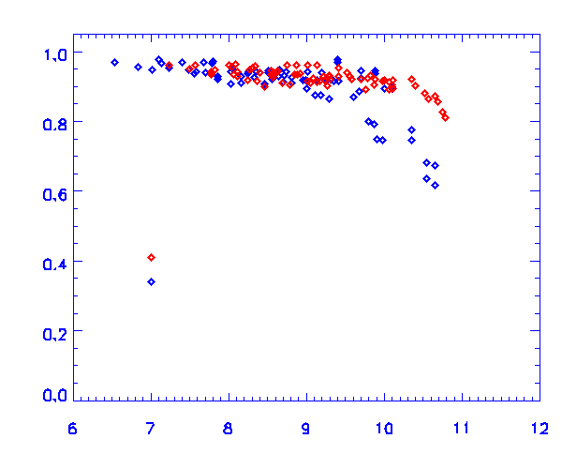
QE
Log Counts
Flight style tube
Development tube

Figure 2: Quantification of cumulative damage to the MIC detector

It can be seen from Figure 2 that the quantum efficiency of the flight-style detector is reduced by about 20% after an exposure to about 10¹¹ events.

Damage Budget

The QE reduction caused by exposing the MIC detector to a stellar image depends on the total counts accumulated. This is a function of the count-rate from the star, and the length of the exposure. The stellar count-rate in turn depends on the magnitude and spectral shape (colour) of the star, and the filter through which it is viewed.

The main issue of concern is exposure of the detector to bright stars, which might cause a localised reduction in QE, rendering the flat-field response of the detector non-uniform. In addition, over the course of time there will be a slight overall shift in QE of the detector downwards as a result of the cumulative photon damage due to faint stars and the background.

For a random series of pointings on the sky, bright stars will appear at random positions on the detector. The probability that a field star will appear at the same location on the detector in two separate pointings is low. Assuming that damage from a particular star is confined to a region of 10 arcsec surrounding it (as indicated by laboratory measurements) then there are 10,000 separate `damage pixels' on the detector. However, most targets of interest will be in the central regions of the detector, and will be distributed over proportionally fewer `damage pixels'.
In establishing a damage budget for the detector, therefore, it is logical to consider the inner and outer regions of the detector separately, and to allocate more conservative limits to the central region. I suggest that the inner region of the detector be defined as that within 2 arc minutes of the centre (4-arcmin diameter), as illustrated in Figure 3.

L_{out}
L_{in}
17 arc min
4 arc min

Figure 3: Damage budget zones on the XMM-OM detector

The value of L_{in} and L_{out} should be reviewed in the light of post-launch data, but as a working assumption I take L_{in}=0.01C* and L_{out}=0.05C* where C* is the count-dose which results in a 20% loss of QE.

Magnitude limits

The magnitude threshold for a given stellar spectral type and a given filter is given by:

$$M=−2\text{.}5\text{log}(S(\text{Sp},\text{Flt})L/T)$$

where L = L_{in} for r<2 arcmin and L = L_{out} for r>2 arcmin. S(Sp,Flt) is a function of both the stellar spectral type and the XMM-OM filter used, and is tabulated in Table 1. This can be used to flag observations that will significantly consume the QE `budget' at a particular point on the detector. (Of course, it is then a science decision as to whether the consumption of that budget is warranted!)

Table 1: S as a function of XMM-OM filter and stellar spectral type.

 | Spectral Type
Filter | B0 | A0 | F0 | G0 | G2 | K0 | M0
UVW2 | 1.63E+00 | 1.25E+01 | 1.52E+02 | 9.32E+02 | 1.62E+03 | 9.35E+03 | 2.94E+04
UVM2 | 1.36E+00 | 9.67E+00 | 7.89E+01 | 4.21E+02 | 5.29E+02 | 6.38E+03 | 6.00E+04
UVW1 | 7.92E-01 | 4.74E+00 | 1.21E+01 | 2.00E+01 | 2.44E+01 | 1.37E+02 | 1.24E+03
U | 6.02E-01 | 2.27E+00 | 3.47E+00 | 4.61E+00 | 5.37E+00 | 1.07E+01 | 7.83E+01
B | 8.97E-01 | 1.07E+00 | 1.48E+00 | 1.87E+00 | 2.20E+00 | 2.45E+00 | 4.34E+00
V | 4.75E+00 | 4.87E+00 | 5.03E+00 | 5.06E+00 | 4.98E+00 | 5.16E+00 | 5.40E+00
White | 1.20E-01 | 4.03E-01 | 6.89E-01 | 8.67E-01 | 9.68E-01 | 1.18E+00 | 1.69E+00

In practice, XMM-OM observations of a given target will consist of a series of exposures in different filters, so it is necessary to consider the cumulative dose from all filters during the observation. Thus it is more useful to consider the total count dose accumulated in each filter as a fraction of the maximum count threshold, C*. Thus for a star of magnitude m and spectral type Sp, the total counts accumulated as a fraction, F, of C* is:

$$F={\sum_{\text{filt}}{c(\text{Flt},m,\text{Sp})t(\text{Flt})}}/{C^{}}$$
where c(Flt,m,Sp) is the count rate in filter Flt. This can be computed from Table 2, which lists the count rate, c₁₀, predicted from a V=10 magnitude star as a function of XMM-OM filter and spectral type. Thus

$$c(\text{Flt},m,\text{Sp})=c_{\text{10}}(\text{Flt},\text{Sp}){\text{10}}^{(\text{10}−m)/2\text{.}5}$$

The count limits are not violated provided that F<L_{in} within 2 arcmin of the centre of the field of view or F<L_{out} for larger radii.

Table 2: c₁₀, count rate per second for a V=10 star as a function of spectral type and filter

Filter | B0 | A0 | F0 | G0 | G2 | K0 | M0
UVW2 | 5534 | 722 | 59.2 | 9.66 | 5.54 | 0.963 | 0.306
UVM2 | 6599 | 931 | 114 | 21.4 | 17 | 1.41 | 0.15
UVW1 | 11368 | 1898 | 744 | 449 | 369 | 65.5 | 7.23
U | 14945 | 3962 | 2596 | 1952 | 1676 | 845 | 115
B | 10035 | 8384 | 6070 | 4806 | 4094 | 3675 | 2075
V | 1893 | 1847 | 1790 | 1778 | 1806 | 1743 | 1667
White | 75280 | 22335 | 13055 | 10376 | 9293 | 7636 | 5323

Observation Target

It is also of interest to consider the effect of the target of the observation on the detector in terms of cumulative damage. The maximum count rate that can be registered with the MIC detectors before encountering coincidence losses is about 40 c/s in full-frame mode, increasing to perhaps 200 c/s if a small science window is used. Thus, in the worst case of exposing continuously at the coincidence threshold for a small science window, the QE of the detector is reduced by 20% in 15 years. Thus, no special precautions need to be taken for the target beyond ensuring that it does not exceed the coincidence threshold.

