Solar-B EIS
CCD Test Programme

Test of Engineering model CCD s/n - 00352-02-04

3.2.1 Flat field
A flat field was obtained by using a light emitting diode with a diffusing screen placed between the diode and the CCD. As these measurements were made at room temperature a dark signal measurement was also taken, and this has been subtracted from the original flat field measurement to produce the flat field shown below (figure one).

Figure one, the flat field image at room temperature. The data has been scaled from 0 to 256 grey levels, with 0 set to the minimum level in the flat field, and 256 set to the maximum. At the extreme left of the image there appears to be a number of hot pixels, and there are a number of column defects some 200 pixels or so to the right. Both these features appear to be cosmetic defects within the silicon itself. The 'blob' type smudge that appears further to the left is probably just a smudge on the cover glass or surface of the silicon.
Figure two below shows the same flat field image but without any scaling of the data.
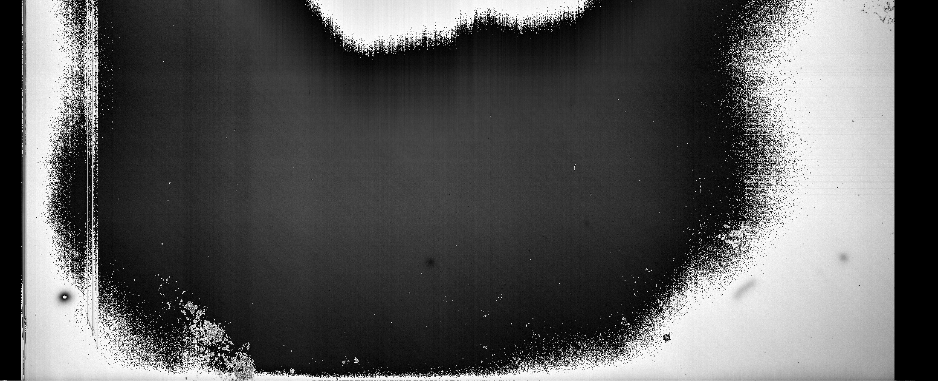
Subtle diagonal striations are visible on the unscaled flat field image. These are probably just slight variations in Quantum Efficiency accross the CCD caused by processing factors.
Figure three shows a histogram of the data accross row 100.

The mean of the image is 1288 with a standard deviation of 46. There are also 51 pixels with values below zero in the dark image. The maximum pixel value in the image is 3052 DN. A clearer picture
of the uniformity (or otherwise) of the flat field can be found if all values above and below 3 standard deviations
are scaled to either 0 or 256 respectively. The cosmetic blemishes are still present (as the values of these
blemishes have simply been re-scaled rather than removed). Figure four shows the new image obtained.

Finally, all pixels which have values greater or less than three times the standard deviation have been replaced by the mean value.

3.2.2 Hot Pixels
Hot pixels are pixels which produce greater than 25,000 electrons per second.
The hot pixels are found by examining the flat field image (In this particular case not corrected for dark current
as this would have the effect of removing most of the hot pixels). As the measurements were taken at room temperature, only the first 500 rows will be displayed which corresponded to values up to 242 DN. Within this section of the CCD, there are 3749 pixels with dark current greater than 25,0000 electrons. This corresponds to about 0.3% of the total available pixels. Most of these should be associated with the column defects identfied above.
An alternative way of defining hot pixels is to indentify hot pixels which have an intensity which is much larger than the local mean. For example, accross a single row. This has been done, with hot pixels defined as those that are 3 times the local mean value. In this case there are 8033 hot pixels. Note that the first 100 rows have been excluded due to poor statistics caused by the low counts.

The following image displays pixels which have a signal over 3 sigma times the mean signal, with all other pixels being set to zero.

In this case, 8033 pixels had a value more than 3 sigma times the mean (0.3%).

3.2.3 Dark pixels
Dark pixels are defined as those pixels which have an output below 80% of the local mean output (a 32 by 32 pixel area). There are 4445 such pixels.
Also, there are 9193 pixels which have an output <80% of the overall mean output (0.4%).

3.2.4 Photo Response Non Uniformity
The PRNU represents the percentage difference between a pixel and and the average signal from an array of 32 by 32 pixels. The PRNU is obtained by calculating the standard deviations of pixel signals in 32 by 32 pixel blocks. The mean of this standard deviation is the local PRNU. The global PRNU is the standard deviation of all the signals.
The local PRNU is 3.6% of the mean local signal . The global PRNU is 22% of the overall signal.

3.2.5 Variation in the mean dark current
Using the INTEGRAL camera hardware the substrate voltage is varied between 8.0 and 11.0 volts to determine the optimum settings to minimise the dark current.
The variation in dark current with substrate voltage is shown below:

3.3.1 Linearity and output amplifier saturation level
This is still to be completed.

3.3.2 Full Well
Full well is defined as where the pixel intensity departs from the straight line fit of the previous points by 3%.

In this case full well is approached far early than would be expected. Full well occurs at about 1600 DN. Full well would be expected around 2300 DN.

3.3.3 Bias offset value and Read noise
For this CCD, there is a cosmetic defect very close to the 50 lead in pixels. Consequently, the final 50 pixels will be used. The following plot shows the change in intensity for the final 50 pixels.
This plot does not show any counts at all for either the lead in or the lead out pixels.
The readout noise can be calculated from the intercept on the light transfer curve (ltc). An ltc is shown below:

