Solar B - EIS

MULLARD SPACE SCIENCE LABORATORY
UNIVERSITY COLLEGE LONDON | Author: W Oliver

SOLAR B -EIS ACTION ITEM 251

Document Number: MSSL/SLB-EIS/TN/006.01 22 February 2000

Distribution:
NRL |  | G Doschek
 |  | C Korendyke
 |  | S Myers
 |  | C Brown
 |  | K Dere
 |  | J Mariska
ISAS |  | H Hara
 |  | T Watanabe
RAL |  | J Lang
 |  | B Kent
 |  | D Pike
BU |  | C Castelli
 |  | S Mahmoud
 |  | G Simnett
 |  | I Butler
Mullard Space Science Laboratory |  | J L Culhane
 |  | A Smith |  |  | .
 |  | L Harra
 |  | A McCalden
 |  | C McFee
 |  | R Chaudery
 |  | P Thomas
 |  | W Oliver
 |  | P Coker
 |  | R Gowen
 |  | K Al Janabi
 |  | M Whillock
SLB-EIS Project Office |  | A Dibbens |  |  | Orig
Author: |  |  | Date:
Authorised By: |  |  | Date:
Distributed: |  |  | Date:
Solar B Action 251

Calculation of the parasitic heat loads into the EIS CCD Camera

In order to assess the parasitic heat loads into the CCD camera the following assumptions have been made:

- The temperature of the EIS structure is in the range –10 °C to +20 °C
(boundary assumption).
- The temperature of the EIS CCDs will be in the range –40 °C to –90 °C (boundary assumption).
- No radiation between the CCDs and EIS structure and between the CCDs and the ROE box (considered a small effect).
- The ROE box has an internal dissipation of 7.1 watts.

Three models were considered:

- CCD camera mounted onto the ROE box with Titanium mount.

The CCD camera head is mounted onto the ROE box on an aluminium bracket. The CCD camera head consists of an invar plate and titanium mount, see Figure 1. The combined thermal conductance between the CCD and the ROE is 0.17 w/K. 2 ribbon cables connects the CCDs to the ROE box. Each ribbon cable is assumed to be 60 mm long with 40x28 AWG cu cables providing a conductance of 0.04 w/K. The ROE box is dry mounted to the EIS structure with a joint conductance across the box base plate of 1.4 w/K.

- CCD camera mounted onto the ROE box with GFRP mount.

The CCD camera head is mounted onto the ROE box on an aluminium bracket. The CCD camera head consists of an invar plate and GFRP mount, see Figure 1. The combined thermal conductance between the CCD and the ROE is 0.0026 w/K. 2 ribbon cables connects the CCDs to the ROE box. Each ribbon cable is assumed to be 60 mm long with 40x28 AWG cu cables providing a conductance of 0.04 w/K. The ROE box is dry mounted to the EIS structure with a joint conductance across the box base plate of 1.4 w/K.

- CCD camera mounted directly onto EIS structure with a GFRP mount.

The CCD camera head is mounted on an aluminium bracket. The CCD camera head consists of an invar plate and GFRP support, see Figure 2. The combined thermal conductance between the CCD and the EIS structure is 0.0026 w/K. 2 ribbon cables connects the CCDs to the ROE box. Each ribbon cable is assumed to be 60 mm long with 40x28 AWG cu cables providing a conductance of 0.04 w/K. The ROE box is dry mounted to the EIS structure with a joint conductance across the box base plate of 1.4 w/K.
Results

The results for model (a) are shown below in Figure 3

Figure 3
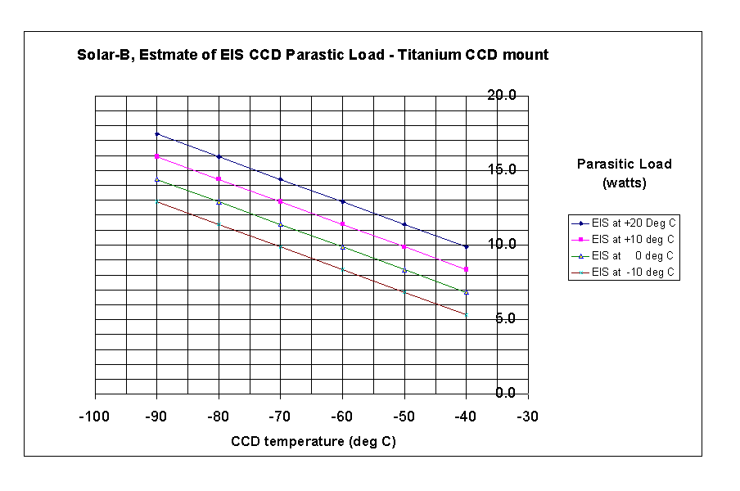
Depending upon the assumptions for the EIS and CCD boundary temperature the parasitic heat loads are in the range 5 watts to 16.5 watts. The thermal design of the mount is not optimised but the order of magnitude of the parasitic loads are consider too high.

Changing the mount from Titanium to GFRP significantly reduces the parasitic loads on the CCD. The results are shown in Figure 4.

Figure 4
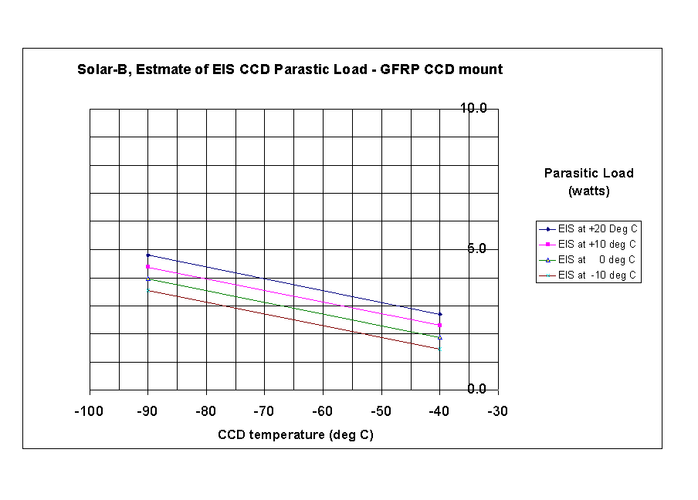

With a GFRP mount the parasitic heat loads are in the range 1watt to 5 watt. Moving the camera head bracket off the ROE box (currently baseline) reduces the parasitic slightly from the above figures.

As a first approximation Birmingham are advised to use the data provided in Figure 4. In the detailed design MSSL will minimise the thermal conductance of the camera mount in order to minimise the parasitic heat loads effectively improving on the values in Figure 4.

