EIS Telescopes: A white paper for trade studies

C. M. Brown NRL code 7674 draft 2/17/99

EIS-sys-des-teltrad

1

Requirement: The requirement is to focus the image of a solar active region on the slit of a stigmatic spectrometer and to scan that image across the slit in such a way that a series of spectal scans can be added to construct monochromatic spatial images in various spectral lines. A potential requirement is that the telescope have internally the capability of adjusting it’s boresight to the optical axis of other Solar-B payloads. Typical Solar-A boresight errors of ~3 arc min have been assumed for this requirement.

Designs: There two candidate EIS designs, a three optical element ( Cassegrain type telescope – “CASS”) that was the subject of the NRL proposal and a two optical element (off-axis parabola “OAP” type telescope) that constitutes the original 1.5m TRENDY strawman instrument The Cassegrain design is assumed to steer it’s image to the slit plane by motions of the secondary mirror, the OAP by motions of the primary.

Case studies: There were several studies made to explore the effects of scanning the solar image across the slit. In both cases, the slit was assumed to be 500 arc sec long (±4.16 min) in the Y direction and 13.5 μm wide (1 arc sec CASS, 1.86 arc sec OAP) in the X direction. The criterion was that the image of a point on the solar surface be imaged into a pixel. A nominal scan range of ±4 arc min in X was assumed to be required to construct an image of a region of interest. Additional range of image motion might be required if the mirror tilt/translation is used to correct boresight differences between EIS and other Solar-B instruments. Maximum use of symmetry was used to keep the ray tracing to a minimum. A similar spectrometer is assumed for both cases

The designs were studied by ray tracing using the Beam-4 software. The input files are as below, most of the parameters are self-explanatory and give the optical layout. The coordinates are as follows: Z is the anti-solar direction, Y is parallel to the slit, and X is perpendicular to these two. Light initially propagates in the +Z direction. Curv is the reciprocal of the central radius, K is the conic constant, 0 being a parabola and –3.37 being an ellipsoid. Xvx, Yvx, and Zvx are the coordinates of the vertex of each optical element in mm (although the units are transparent in the raytrace). The full size TRENDY has been assumed, but the raytrace is scalable.

For the Cassegrain telescope:

OD ID Xvx Pitch Zvx Curv K Mir/Lens
200 : 60.:0.0: 0.0 : 0.1 : : : Iris
200 : 60.:0.0 0.0 : 1000. : -0.0005 : 0.00 : Mir :
60. :0.0: 0.0 : 300. : -0.00107843: -3.371901: Mir :
60 : :0.0 0.0 : 1000. : : : Iris:
20. :0.0: 0.0 : 1150. : : : Detr:

For the off-axis parabola:

Xvx Yvx Zvx Pitch Tilt c K M f D
125.: 0.0 :1490.000b : : : : Iris:s:151.:
0 : 0.0 :1500.000: : :-.000333: 0: Mir :s:402. :
0 : 0.0 : -1.5015: : : 0. : : Detr:s: 50. :

Three basic studies were made for each telescope. 1. A study of the telescope image on the slit plane. Calculated were points at Y=0 (center line) and Y= +250 arc sec (slit top) for various values of the X offset between 0 and 4 arc min. 2. A study of images on the slit formed by a simple tilt about Y of the image steering mirror (secondary in the case of the Cassegrain and primary in the case of Trendy). Again, points at the top and center of the slit were calculated. 3. A study of images formed by tilting and decentering the image steering mirror. Images as in case 2 were studied.

Cassegrain Telescope

In case 1, the telescope is an imager and was used as in the original NRL proposal to feed a pair of detector arrays on the slit jaws. This slit jaw imager has been eliminated in the current program. The calculation was used to optimize the mirror curvatures and focus. The resulting spot diagrams are given here for the curious.
0
1
2
3
4

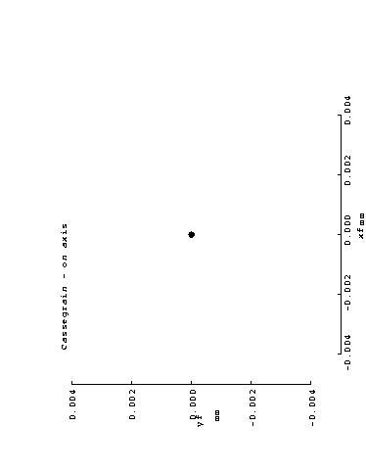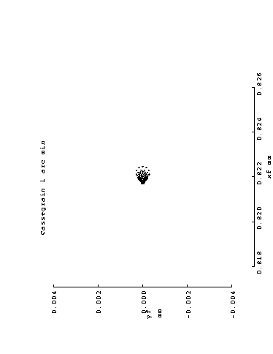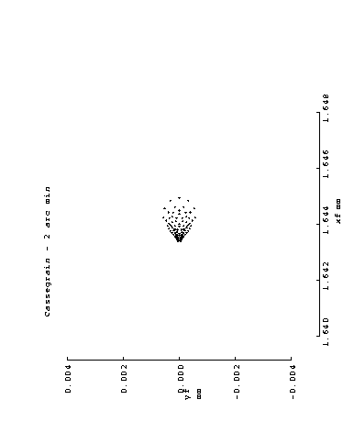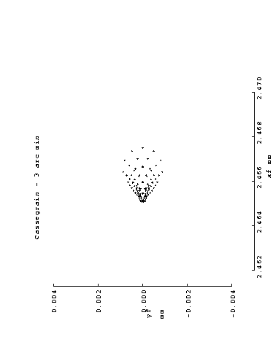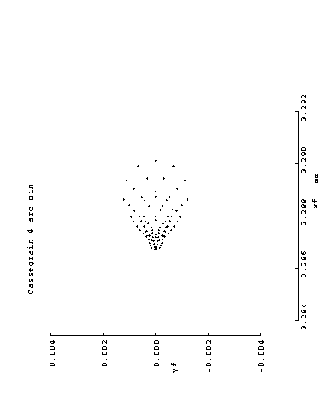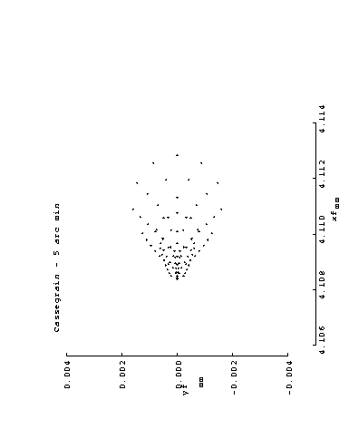
Figure 1 Cassegrain spot diagrams in the focal plane for various offsets between 0 and 5 arc min. The tics on the plots are 2 microns.

It is clear in Figure 2 that the simple tilt of the secondary is limited in its range to about 5 arc min. This led to a calculation of a more complex motion of the secondary combining a tilt with a decenter to improve the imaging.

Cassegrain pitch & decenter are represented as a rotation of the secondary about a point on the optical axis, 352 mm behind the secondary. This is near the virtual focus of the primary, which is 300 mm behind the secondary. Such a mechanism would have to be designed, and the ranges of motion are beyond the normal range of piezo actuators. A smaller version of the SUMER mechanism might be used.

Table 1. Tilts & decenters for a Cassegrain telescope secondary as derived from raytrace optimization.

Offset angle (arc min) | Secondary Pitch (deg) | Secondary Decenter (mm)
0.0 | 0.0 | 0.0
0.5 | -0.02235 | -0.1376
1 | -0.0447 | -0.275
1.5 | -0.06715 | -0.4129
2 | -0.0893 | -0.5482
2.5 | -0.11177 | -0.6854
3 | -0.13431 | -0.8261
4 | -0.17882 | -1.0967
5 | -0.22283 | -1.3591

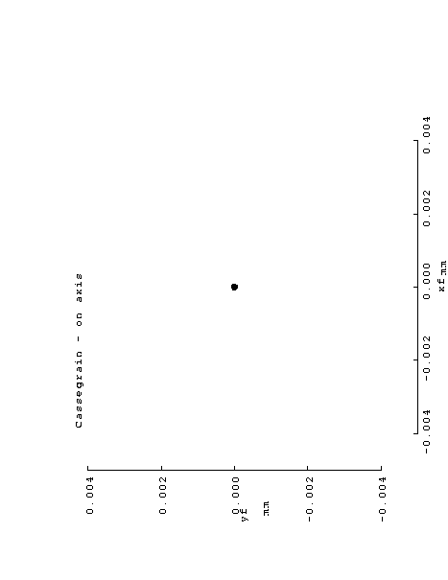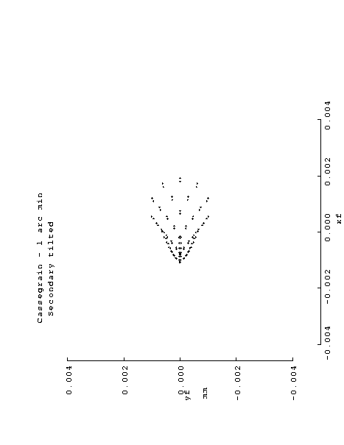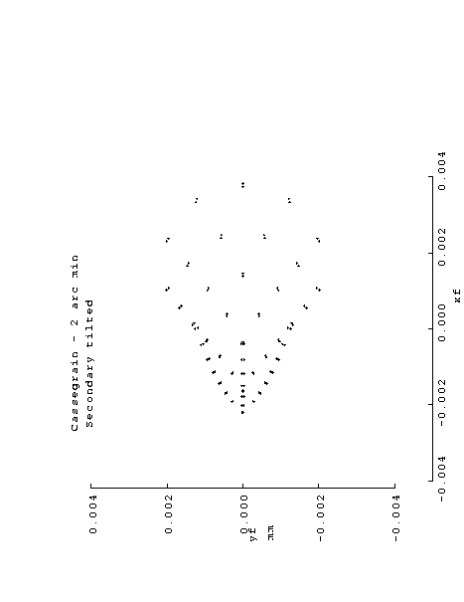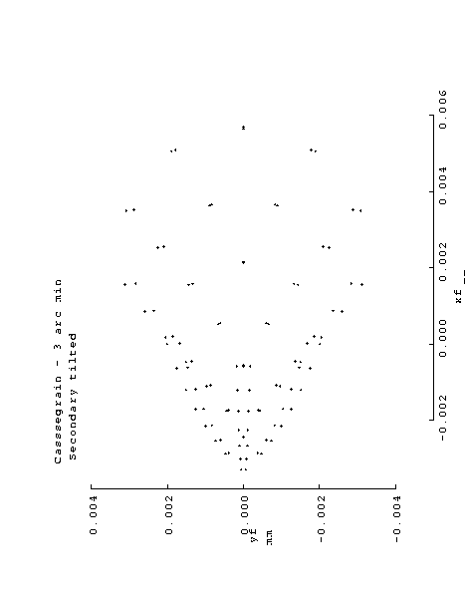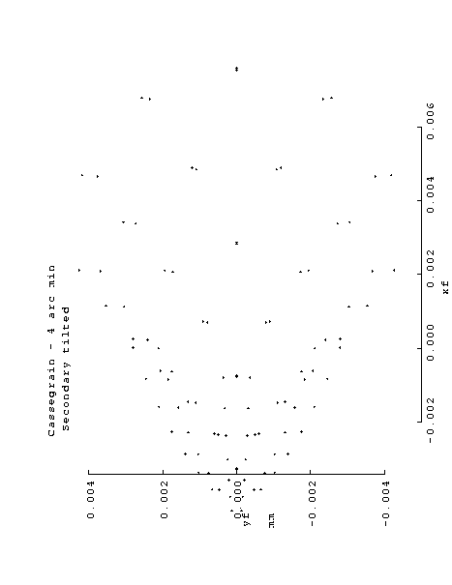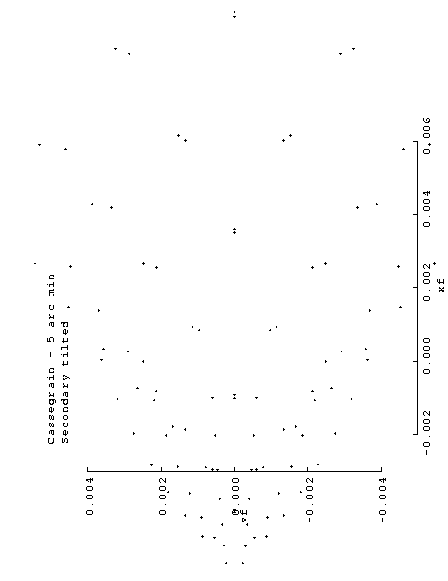
Figure 2 Here, the secondary is tilted to move a desired point into the center of the slit. The offsets range from 0 to 5 arc min in the figures. Negative offsets should produce a mirror image of these spots
5
0
1
3
3
4

Figure 3 Plot of Pitch and decenter of Casssegrain secondary as a function of offset angle

The Pitch is given by the linear relation

Pitch (deg) = -0.000065 - 0.04465 X Offset (arc min)

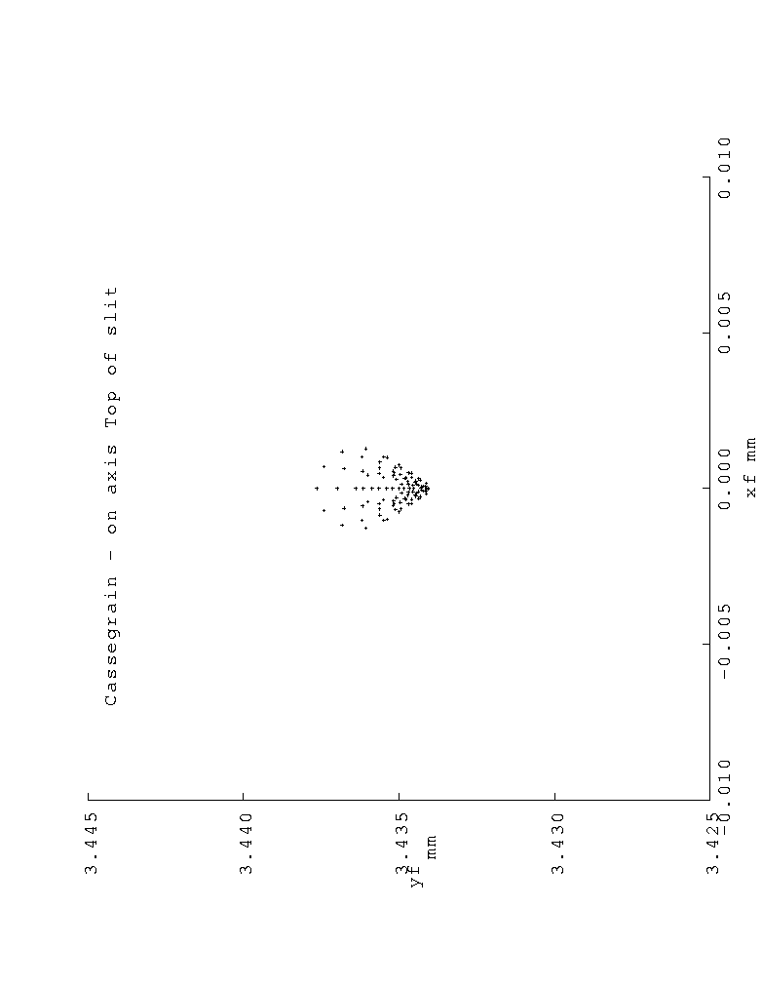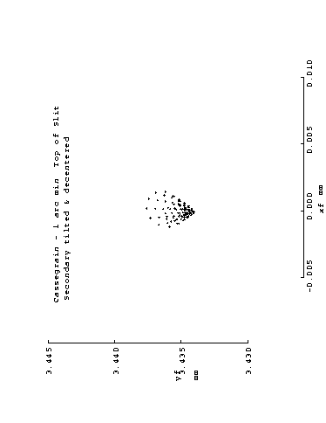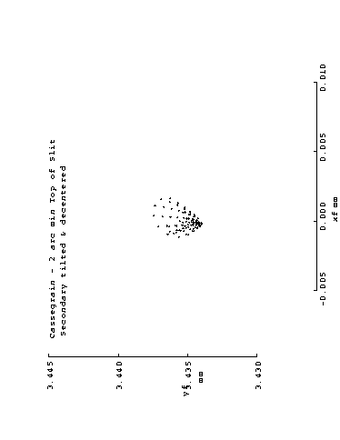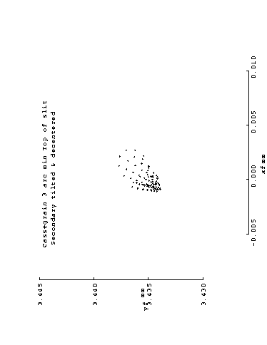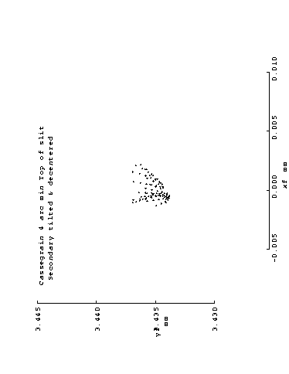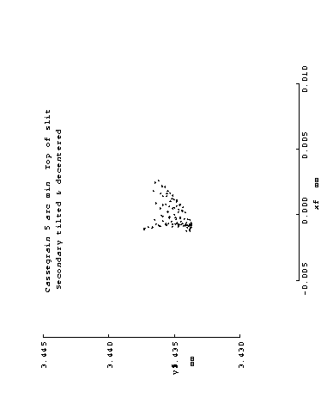
Figure 4 Spot diagrams for tilted & decentered Cassegrain telescope – end of slit 0 – 5 arc min central offsets.
0
1
2
3
4
5
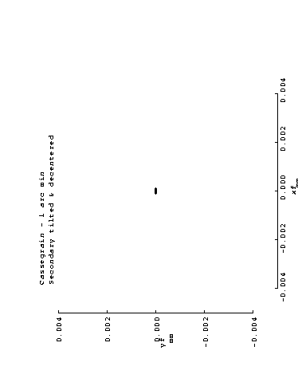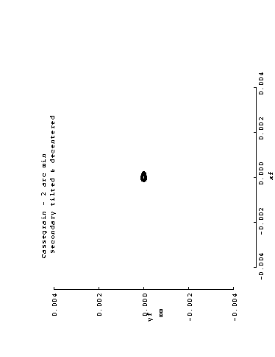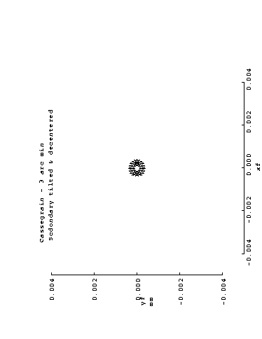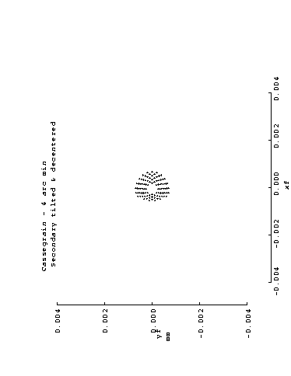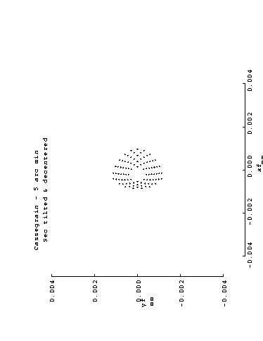
Figure 5. Results for Cassegrain with tilted & decentered secondary for offsets of 0 – 5 arc min. Slit center.
There were lots more individual ray traces done, but the conclusions are that the simple tilt of the secondary is limited in its useful range to angles less than about 5 arc min. A cassegrain with the tilt & decenter capability in its secondary motion is useful over at least twice the range.

Off Axis Parabola Telescope

The Paraboloid is of course perfect for a point on it’s axis, but is notorious for it’s off axis performance. The figures in this section are at half the enlargement of the corresponding figures in the Cassegrain section. Fig. 6 is a look at points at various offsets in the focal plane of a parabola. The ends of the slit are approximately like the 4 arc min image with a 90° rotation.
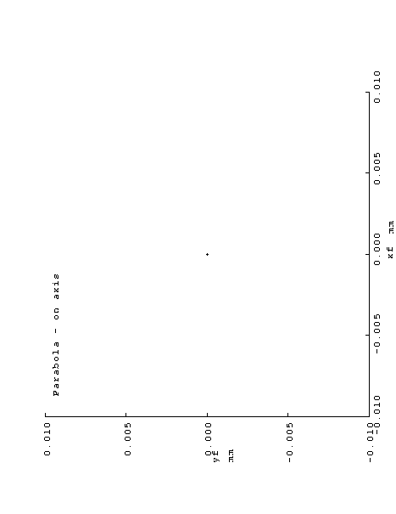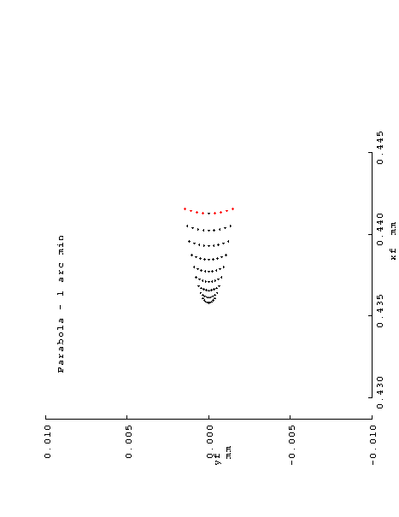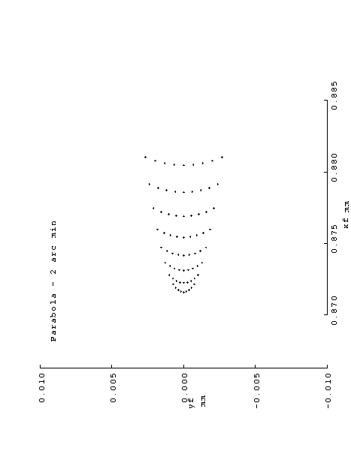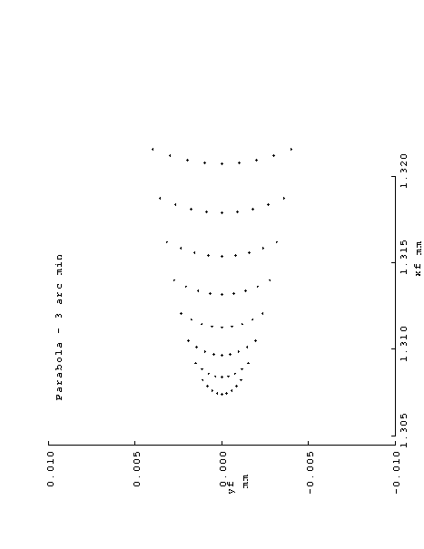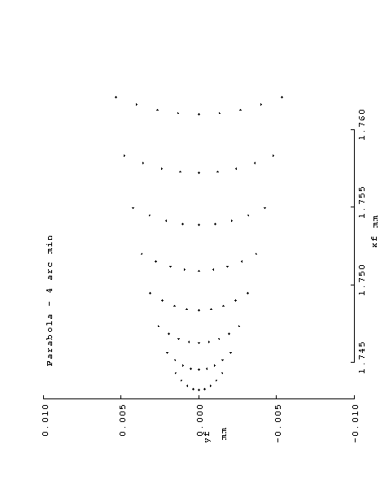
Figure 6 Spot diagram for a parabolic mirror for offsets from 0 to 4 arc min. The tic marks are at 5 micron intervals.

Table 2 summarizes the necessary motions of the OAP primary to bring a desired point to focus at the slit center. The first two columns describe a simple pitch of the mirror about its vertex. The pitch is essentially half the offset. The last three columns describe the compound motion. The pitch is equal to the offset angle and the decenter is the movement of the OAP’s vertex. This movement is in a circular arc centered at the slit (focal point of OAP).

Table 2. Mirror motions for the OAP designs
OAP tilt only |  |  |  | OAP tilt & decenter
Offset (arc min) | Pitch (deg) |  |  |  | Pitch (deg) | Decenter (mm) | R(mm)
1 | +0.0083 |  |  |  | +0.0166 | 0.4354 | 1501.3
2 | +0.0166 |  |  |  | +0.0332 | 0.8709 | 1501.5
3 | +0.0249 |  |  |  | +0.0498 | 1.3063 | 1501.5
4 | +0.0332 |  |  |  | +0.0664 | 1.7417 | 1501.5
5 | +0.0416 |  |  |  | +0.0833 | 2.1810 | 1501.5

Tilting of the parabola is a method that lends itself to a simple scan mechanism. If the parabola is enclosed in a gimbal and pivots on Bendix “Flexpivots”, a reliable mechanism can be designed with piezo stacks as drivers for small angles. The large primary mirror tilts by the offset angle, so disturbance torques are moderate, Launch locks would likely be required to protect the piezo devices from the massive mirror.
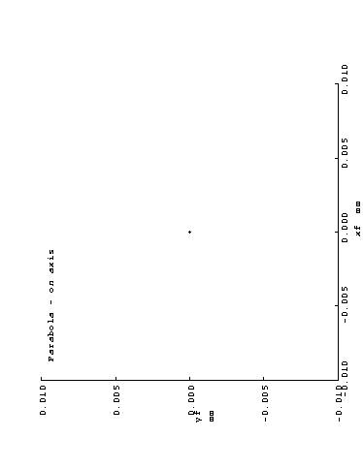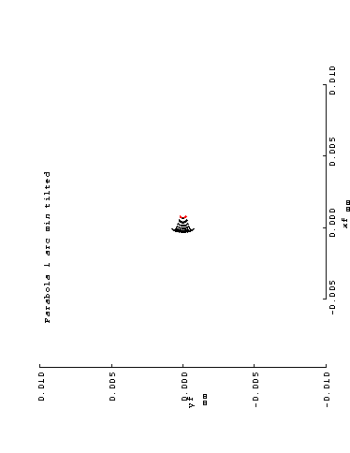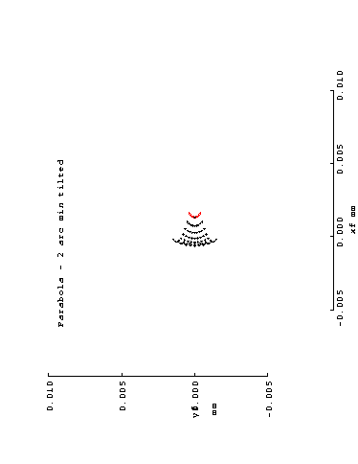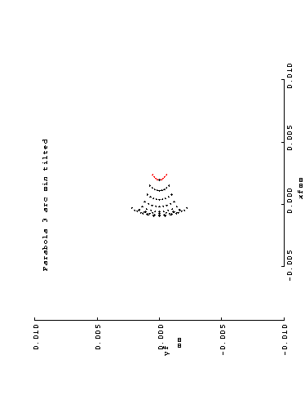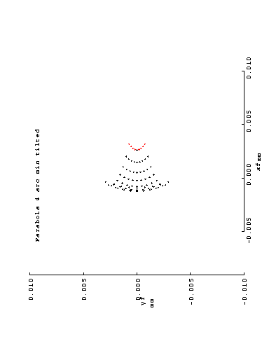
Figure 7. On-axis spot diagrams for tilted parabolic mirror as a function of tilt for 0 – 4 arc min

More elaborate would be a SUMER-type motion of the primary, where the mirror approximates a rotation about it’s focal point at the center of the slit. The image at slit center is perfect in this case, so no spot diagrams are shown here. Likewise, at the ends of the slit, the spot diagram is approximately like the 4 arc min spot in Fig. 6 (with a 90° rotation) so it is not repeated.

In the SUMER mechanism, the motion of the primary mirror is guided by two sets of linear slides tangent to a sphere centered at the slit. The movements are comparatively large and so are the disturbance torques. Stepping motors and lead screws will likely be required in place of piezo drivers. The SUMER mechanism was life tested for the SOHO mission, and qualified, however it failed early in the mission. The failure was analyzed by MPAE and traced to the pre-load on a bearing being greater than specifications in the flight model

As can be seen, the Parabola suffers at the end of the slit in this arrangement. However, over 75% of the encircled energy is found to be within one pixel (1.86 arc sec) even at the end of the slit.
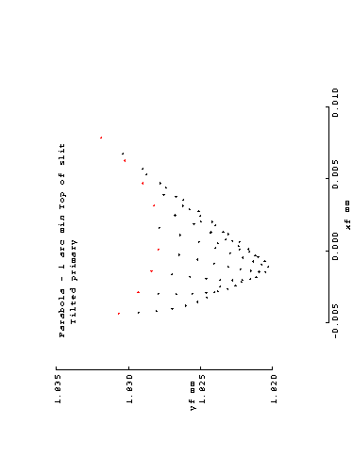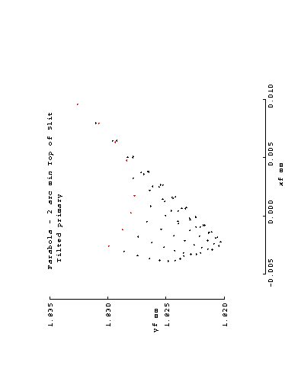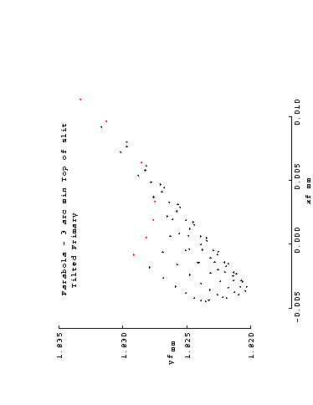
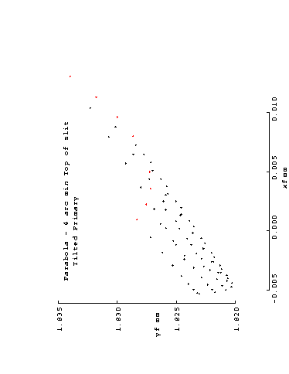
Figure 8 Spot diagrams for tilted parabola for off-axis points - at end of slit – offsets from 0 – 4 arc min.

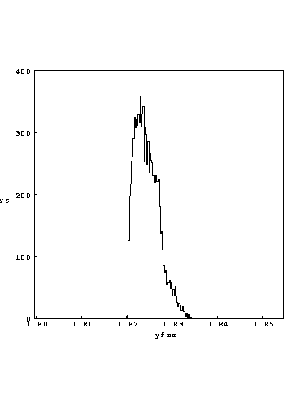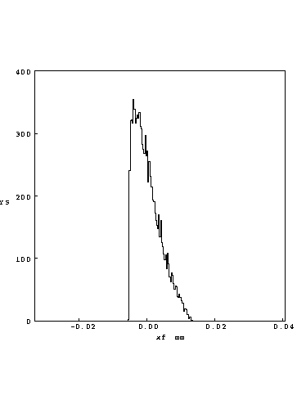
Figure 8 X and Y ray distributions at the end of the slit for a tilted parabolic mirror

Conclusions
The OAP delivers a lower scale factor than the CASS, 7.25 microns/arc sec vs 13.5 microns/ arc sec and might require a finer slit for equivalent resolution.
Both telescopes will perform optically as required, and scanning will require at least a tilt mechanism for a mirror. In the case of the Cassegrain, it is the secondary and in the case of the Parabola it is the primary mirror. The simple tilts can be accomplished by putting the mirror in a 2 axis gimbal and tilting it about its vertex with two piezo actuators. Both systems begin to show appreciable aberrations above about 4 arc min, with the Cassegrain being marginally better over the majority of the field.
Better performance can be had in both systems by rotating the mirror in question about a point other than its vertex. The Parabola can then always have the center of the slit on its axis, and the Cassegrain will be very good at the center of the slit and better than the OAP at the extremes of the FOV. In this mode, both can more easily accommodate pointing offsets to boresight with other instruments

