Space Plasmas & SMILE Primary Workshop

Author: Dr. Jennifer Carter, Department of Physics and Astronomy, University of Leicester. Email: jac48@leicester.ac.uk

Learning objectives (including Solar System optional content)

- Discover that the Earth is a planet in the Solar System
- Discover that the Sun is our star, and the planets orbit about the Sun
- Discover that the Earth has a magnetic field and that this protects us from the solar wind
- Learn that plasma is the fourth state of matter, that plasma is all around us, and can be found in many everyday situations
- Learn about how the solar wind and magnetosphere interact, and how this manifests in phenomena such as the aurora
- Become familiar with terms such as atoms, protons, ions, and electrons
- Learn about the SMILE mission

Relation to the Key Stage 1 and Key Stage 2 curriculum (UK)
(Source: Department of Education Statutory Guidance: National curriculum in England: science programmes of study)

- Space Describe the Sun, Moon, and Earth as approximately spherical bodies
- Space: Describe the movement of the Earth, and other planets, relative to the Sun in the solar system
- Space: Use the idea of the Earth’s rotation to explain day and night and the apparent movement of the sun across the sky
- Forces and magnets: notice that some forces need contact between two objects, but magnetic forces can act at a distance
- Forces and magnets: describe magnets as having two poles
- States of matter: compare and group materials together, according to whether they are solids, liquids or gases
- States of matter: observe that some materials change state when they are heated or cooled, and measure or research the temperature at which this happens in degrees Celsius (°C)

Overview of workshop (see the associated example presentation file)

NOTE: there are several versions of this workshop, and I have several different versions of the slides for the associated presentation file (Keynote or Powerpoint). The workshop can be tailored for the age and/or ability of the group, and depending on the allotted time in class. The basic space plasmas workshop, without talking much about the rest of the Solar System, lasts between 45 minutes and 1 hour, very much class and questions dependent.

Index | Section | Content | Activity & equipment
1. | Introduction | Introduction of speaker, and careers in space. Encourage question asking. | Ask pupils about their perceptions of scientists.
2. | SMILE | Brief introduction to SMILE | Talk about space agencies
3. | [Extra: not included in some versions of presentation file] Our Solar System | Our place in the Solar System. The scales as compared to Leicester. What makes up our Solar System: planets, comets, and other bodies | Discussions with pupils
4. | [Extra: Our Earth] | Orbits as ellipses. Definition of a year and of a day. Tilt of the Earth. Why we have seasons. | - Insolation experiment [easy skip for younger pupils]  - Spinning inflatable Earths.
5. | What is plasma? | Explore states of matter, building on from pupils’ knowledge of solid-liquid-gas. Explore the idea of atoms, electrons, protons, and neutrons. Relate to pupils knowledge of water. The solar wind as plasma. Plasma dance, stressing charge neutrality, getting pupils to count up the number of electrons and protons to sum to zero. | - Atom demonstrator.  - Show ice cubes, water in a flask, and ask pupils about what happens in a kettle  - Plasma dance with pupils acting out being electrons and protons. Other pupils add energy to the system, and the ‘matter’ changes state.
6. | Where can we find plasma? | Everyday examples. | Discussion with pupils about their experiences of plasmas.
7. | How are we protected from the solar wind | Discover that the Earth has a magnetic field, and what this field looks like. How we know the field is there. Discuss where is the magnetic north pole. | - Pupils explore 3D magnets.  - Pupils help with the demonstration of a wooden shield. Discuss consequences of solar wind on satellites.
8. | What happens when the solar wind does get into the Earth’s magnetosphere | Explanation of the Dungey cycle of solar wind entering the Earth’s magnetosphere and causing the aurora in the auroral ovals, but not normally at the poles | Video of the Dungey cycle. Replay as necessary. Talk about the colours of the aurora and relate colour to energy [extra/higher ability only]. Talk about the view of the aurora from space. Talk about the atmosphere. Pupils guess what is in the atmosphere.
9. | How do we create aurora? | Constituents of the atmosphere, how this results in the colours of the aurora. | - Demonstration of the plasma ball. Pupils get to touch the plasma ball with glass tubes to see the inside of the tubes glow.
10. | The SMILE mission | More detail on the mission objectives. | Talk about the mission, the scientists and countries involved. Relate to what has been learnt in the workshop.
11. | [Extra 1] The scale size of the Solar System [dry weather] | Demonstration of scale size of Solar System with 30m tape. | Pupils plot out scale size of Solar System in the playground.
12. | [Extra 2, or wet weather alternatives] | Venus in a jar, surface gravity, spectrometer, Solar System rap found on Spotify or YouTube | Pupil led experiments and creative output. Use as follow-up.

Activity details and associated equipment (in bold below, see some example photos, not all equipment photographed)

- Insolation: One pupil holds a board vertically, so the face is perpendicaular to the ground., Another shines a focused beam from a torch onto the board so that a circular spot is seen, and a third draws around the spot. Experiment by tilting the board away from the beam, and seeing how the same beam is spread over a larger area. Small groups, or one example group.
- Spinning Earths: with inflatable Earths. Get pupils to participate spinning Earths, on a tilt, talk about day and night. Small groups or one example group.
- Atom demonstrator: first mention of electrons and protons and what an atom is, relating to pupils experiences of certain words, e.g. oxygen, carbon. Stress only a model, and cannot easily be made to scale for the classroom
- States of matter: bring in ice cubes and liquid water (not shown), to take the pupils through changes of state (many have covered this by Year 5). Introduce plasma
- Plasma dance: get a group of approximately 4 pairs of pupils to be (hydrogen) atoms and say that we’re going to make a plasma. One of each pair holds an ‘electron’, and one a ‘proton’ to make an atom. These are made of circles of different coloured card on old icecream sticks, with plus and minus signs stuck on. The proton starts by gently swaying, and the electron orbits the proton. The four atoms are arranged near each other, but with sufficient space to move around (solid). The rest of the class adds energy, in the form of heat, by rubbing their hands together and ‘sending’ it to the atoms. The electrons have to orbit faster, and the protons start drifting in the available space (liquid). More heat is added. The protons move faster. The electrons still have to orbit the protons, but this gets harder and harder to stay with their proton (gas). Even more heat gets added. The protons and electrons now are all moving very fast and are all mixed up like a particle soup (plasma). Shout ‘stop!’. Get the pupils to recount the number of positive protons and negative lectrons to stress that plasmas are quasi-neutral.
- Show and hand around magnet in cube with suspended iron fillings (magnetic field in 3D). Relate to experience with bar magnets, showing a simple, individual bar magnet. Extend the idea to the Earth. Magnetics available at Timstar: https://www.timstar.co.uk/ma84015-magnetic-field-box-kit.html
- Magnetopause as a shield: using a toy shield held by one pupil, get another to push lightly then more strongly against the shield. Stress that the magnetopause boundary moves in response to the solar wind and is very dynamic.
- Plasma ball and glass tubes with rarefied gas (e.g. Ne + Hg mix, and Xe + Hg mix): get the pupils to see plasma in action by touching the plasma ball, and also holding the tubes near the ball to make them glow different colours. CARE REQUIRED. Recommended at the end of the class, and pupils come up to the ball in small groups with a maximum of four people at a time.
- [Extras (not shown): inflatable planets of the Solar System, long e.g. 30 m tape with distances to planets marked on it, some pictures of comets, astroids, and minor planets, a pump]

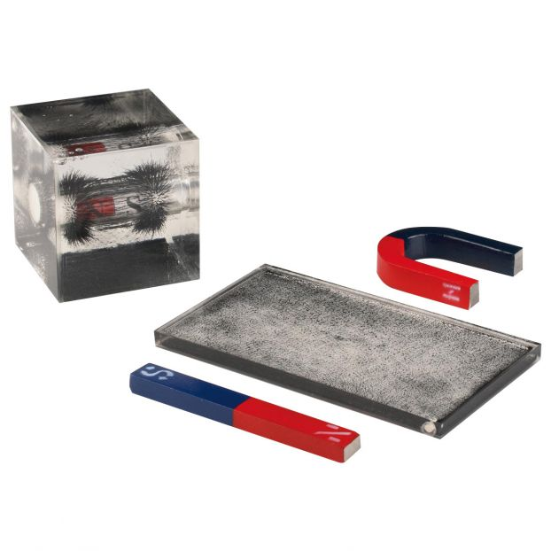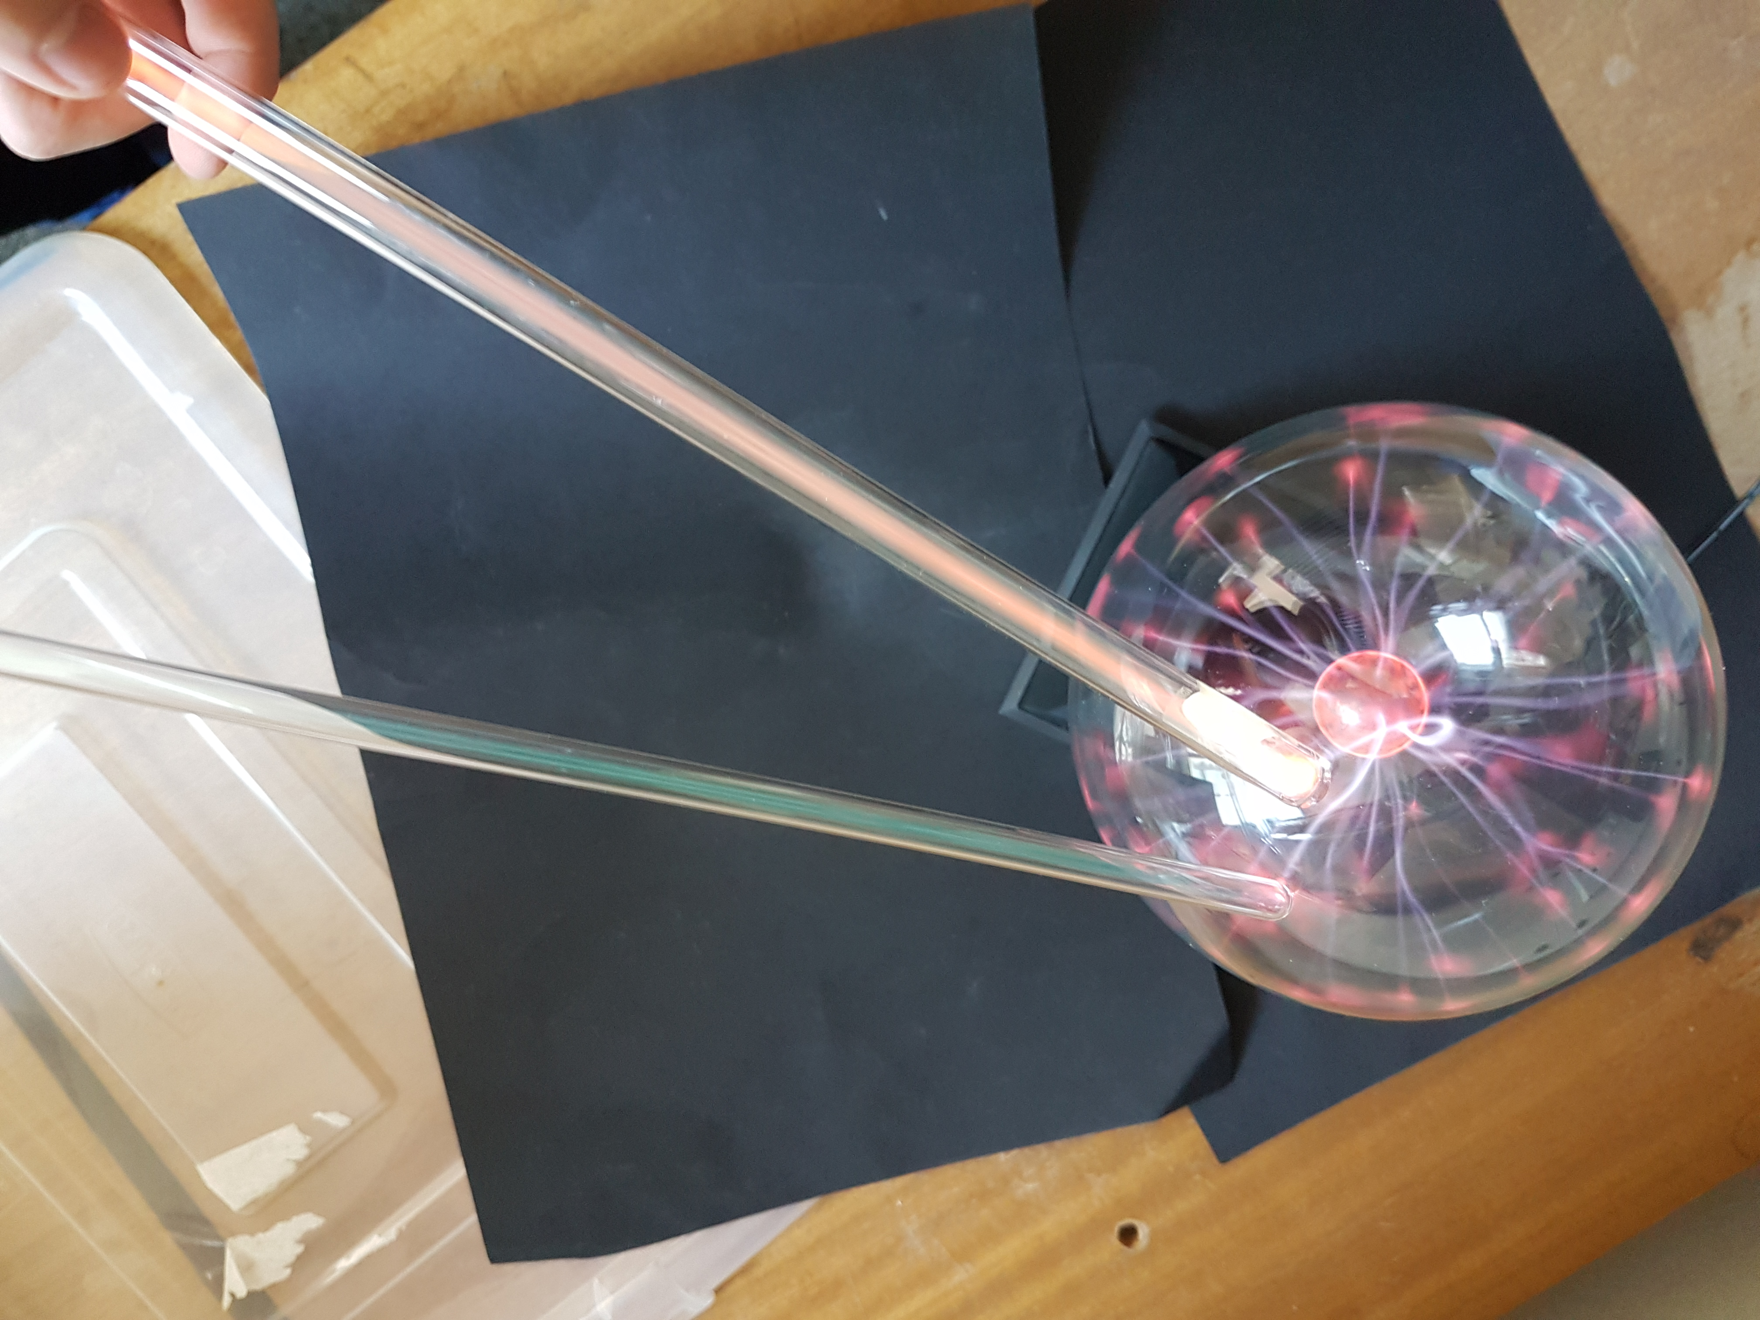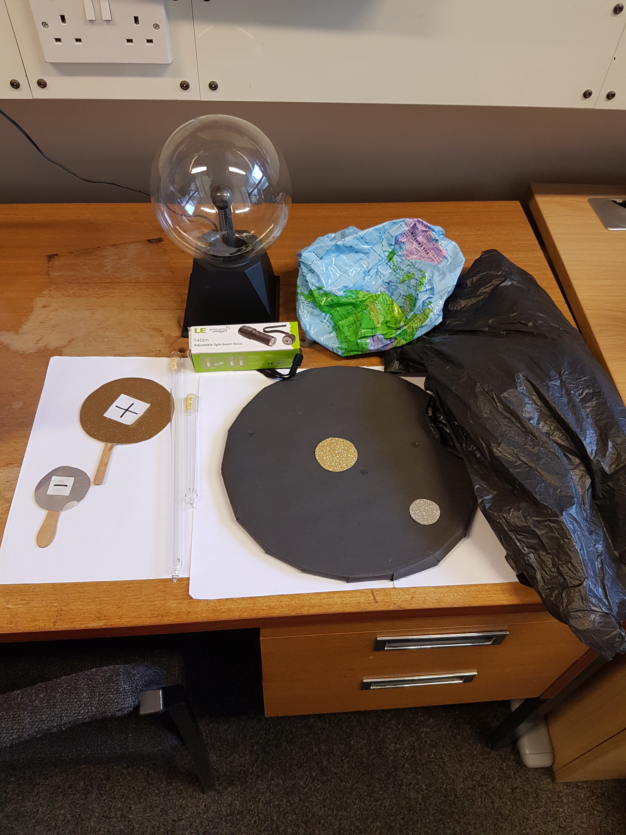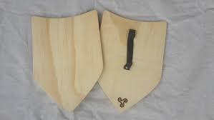
Continued learning ideas

- Email a collated list of questions to the speaker
- Follow websites such as spaceweather.com or follow AuroraWatch UK.
- Build a magnetometer, spectrometer, or run the surface gravity experiment
- Continue learning about the flow of electrons and electricity using magic energy sticks, e.g. https://www.amazon.co.uk/Funtime-ET7560-Energy-Sick/dp/B010DF3CEW/ref=asc_df_B010DF3CEW/?tag=googshopuk-21&linkCode=df0&hvadid=310876852693&hvpos=&hvnetw=g&hvrand=18331631100810780678&hvpone=&hvptwo=&hvqmt=&hvdev=c&hvdvcmdl=&hvlocint=&hvlocphy=9046185&hvtargid=aud-858874965014:pla-328911638098&psc=1&th=1&psc=1
- Draw, paint, write, dance, or act, what you have learnt in the workshop

