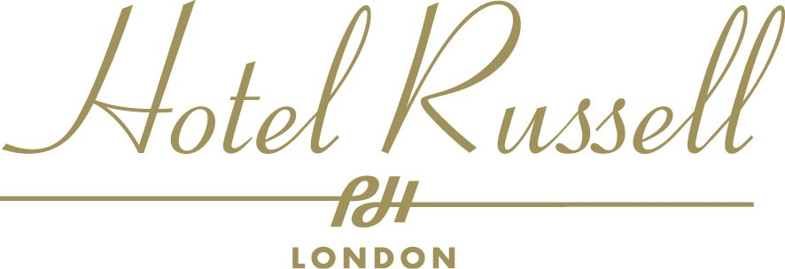

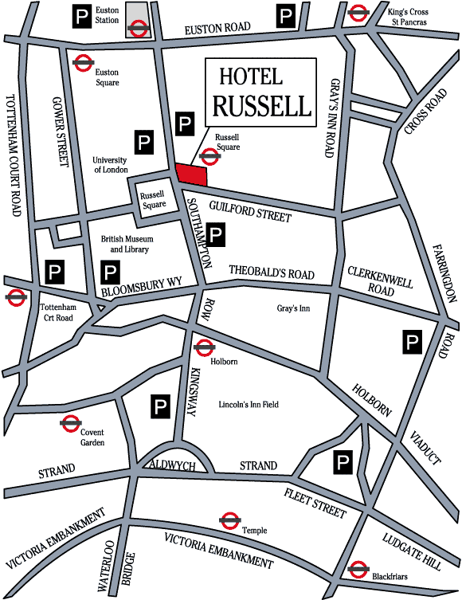Location Map

LONDON UNDERGROUND
- Russell Square Underground Station on the Piccadilly Line, direct to Heathrow Airport in fifty minutes, is one minute away.
- Holborn Underground on the Central Line, is seven minutes walking distance.

BRITISH RAIL MAINLINE STATIONS
- Euston, King’s Cross and St.Pancras mainline British Rail Stations are all within five minutes travelling distance. Waterloo British Rail Station and the Eurostar Terminal are ten minutes by taxi.

BUSES
- Bus numbers 8, 19, 22b, 25, 38, 55, 188, 91, 168, and 68 all stop at Holborn or Russell Square.
- A2 Airbus direct to Heathrow stops at Russell Square.

TAXIS
- A taxi cab rank is situated directly opposite the Hotel, on Russell Square.

CAR PARKING
- Street parking in the vicinity is free between 7.00 p.m. and 7.00 a.m., Monday to Friday, after 13:30 on Saturdays and all day Sunday. A Public Car Park is situated within 200 yards of the Hotel in Herbrand Street.

